- POSIX Threads
  - Password Cracking
- Run the program 10 times and calculate the mean running time.
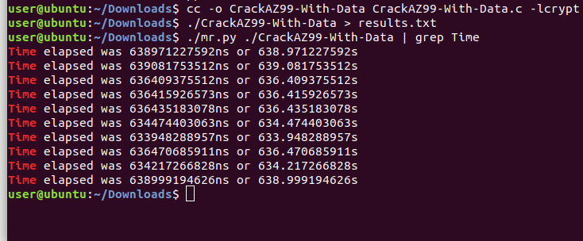

Mean Time in second=

Code of original Program CrackAZ99-With-Data:
#include <stdio.h>
#include <string.h>
#include <stdlib.h>
#include <crypt.h>
#include <time.h>

int n_passwords = 4;

char *encrypted_passwords[] = {
"$6$KB$zi3fXMJevNoChNTJt69vjDIda67syVyENwdw6TIEecnk8q.cRot8X.0c17MG/Xl/M8xYJkjVzxoH9y55sVwXq/",
"$6$KB$1mEnLCYT6mweh/1RJ8B228i/fG4ee1VkVorzrYux4xDwXFxz3Ae5tig5F1uMaekN2HSZfS4bgbBS4.Hta.tjj0",
"$6$KB$Vq2yxyC0KPJn434zm7/nLwULvz2lqpiKtDa6KfsUmKVEjCLBEChhX5UwBWvbEaLgXfFT2I0GyOmhLqRyEyg180",
"$6$KB$5EmaeQErXZCaDfHlnvye6o7t26kJGYSqaoi3ALdPJBc5tGTdY7JyPyAFFfhTVptGSikmfP9mt.saZtsjfgXop0"
};

void substr(char *dest, char *src, int start, int length){
memcpy(dest, src + start, length);
*(dest + length) = '\0';
}

void crack(char *salt_and_encrypted){
int x, y, z,q;
char salt[7];
char plain[7];
char *enc;
int count = 0;

substr(salt, salt_and_encrypted, 0, 6);

for(x='A'; x<='Z'; x++){
for(y='A'; y<='Z'; y++){
for(q='A';q<='Z';q++ ){
for(z=0; z<=99; z++){
sprintf(plain, "%c%c%c%02d", x, y, q, z);
enc = (char *) crypt(plain, salt);
count++;
if(strcmp(salt_and_encrypted, enc) == 0){
printf("#%-8d%s %s\n", count, plain, enc);
} else {
printf(" %-8d%s %s\n", count, plain, enc);
}
}
}
}
}
printf("%d solutions explored\n", count);
}

int time_difference(struct timespec *start, struct timespec *finish,
long long int *difference) {
long long int ds = finish->tv_sec - start->tv_sec;
long long int dn = finish->tv_nsec - start->tv_nsec;

if(dn < 0 ) {
ds--;
dn += 1000000000;
}
*difference = ds * 1000000000 + dn;
return !(*difference > 0);
}

int main() {
int i;
struct timespec start, finish;
long long int time_elapsed;

clock_gettime(CLOCK_MONOTONIC, &start);

for(i=0;i<n_passwords;i<i++) {
crack(encrypted_passwords[i]);
}

clock_gettime(CLOCK_MONOTONIC, &finish);
time_difference(&start, &finish, &time_elapsed);
printf("Time elapsed was %lldns or %0.9lfs\n", time_elapsed,
(time_elapsed/1.0e9));

return 0;
}

- In your learning journal make an estimate of how long it would take to run on the same computer if the number of initials were increased to 3. Include your working in your answer.

- Modify the program to crack the three-initials-two-digits password given in the three initials variable. An example password is JSB99.

Encrypting four passwords with three initials:

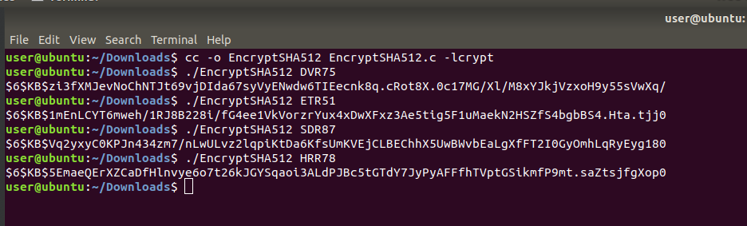

Code:
#include <string.h>
#include <stdio.h>
#include <stdlib.h>
#include <crypt.h>

#define SALT "$6$KB$"

int main(int argc, char *argv[]){

printf("%s\n", crypt(argv[1], SALT));

return 0;
}

Final Cracked password are:
- Write a short paragraph to compare the running time of your three initials program with your earlier estimate. If your estimate was wrong explain why you think that is.

- Modify the original version of the program to run on 2 threads. It does not need to do anything fancy, just follow the following algorithm.

Steps in terminal:
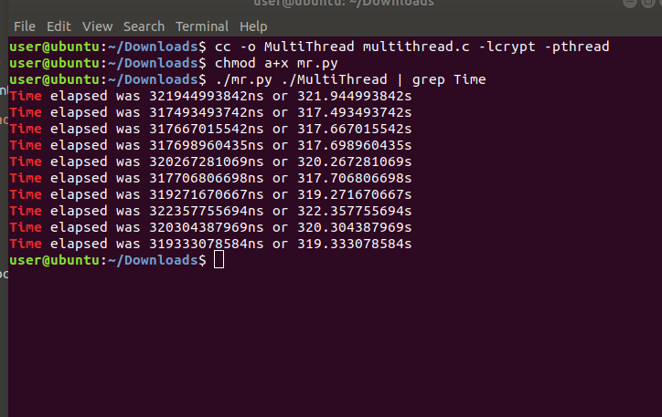

Code:
#include <stdio.h>
#include <string.h>
#include <stdlib.h>
#include <crypt.h>
#include <time.h>
#include <pthread.h>

int n_passwords = 4;

char *encrypted_passwords[] = {
"$6$KB$zi3fXMJevNoChNTJt69vjDIda67syVyENwdw6TIEecnk8q.cRot8X.0c17MG/Xl/M8xYJkjVzxoH9y55sVwXq/",
"$6$KB$1mEnLCYT6mweh/1RJ8B228i/fG4ee1VkVorzrYux4xDwXFxz3Ae5tig5F1uMaekN2HSZfS4bgbBS4.Hta.tjj0",
"$6$KB$Vq2yxyC0KPJn434zm7/nLwULvz2lqpiKtDa6KfsUmKVEjCLBEChhX5UwBWvbEaLgXfFT2I0GyOmhLqRyEyg180",
"$6$KB$5EmaeQErXZCaDfHlnvye6o7t26kJGYSqaoi3ALdPJBc5tGTdY7JyPyAFFfhTVptGSikmfP9mt.saZtsjfgXop0"
};

void substr(char *dest, char *src, int start, int length){
memcpy(dest, src + start, length);
*(dest + length) = '\0';
}

void *function()
{
int i;
pthread_t t1, t2;
void *kernel_function_1();
void *kernel_function_2();

for(i=0;i<n_passwords;i<i++) {
pthread_create(&t1, NULL, kernel_function_1, encrypted_passwords[i]);
pthread_create(&t2, NULL, kernel_function_2, encrypted_passwords[i]);

pthread_join(t1, NULL);
pthread_join(t2, NULL);

}
}

void *kernel_function_1(char *salt_and_encrypted){
int k, a, r;
char salt[7];
char plain[7];
char *enc;
int count = 0;

substr(salt, salt_and_encrypted, 0, 6);

for(k='A'; k<='M'; k++){
for(a='A'; a<='Z'; a++){
for(r=0; r<=99; r++){
sprintf(plain, "%c%c%02d", k, a, r);
enc = (char *) crypt(plain, salt);
count++;
if(strcmp(salt_and_encrypted, enc) == 0){
printf("#%-8d%s %s\n", count, plain, enc);
}
/
}
}
}
printf("%d solutions explored\n", count);
}
void *kernel_function_2(char *salt_and_encrypted){
int b, o, l;f("#%-8d%s %s\n", count, plain, enc);
}
}
}
}
printf("%d solutions explored\n", count);
}
int time_difference(struct timespec *start, struct timespec *finish,
long long int *difference) {
long long int ds = finish->tv_sec - start->tv_sec;
long long int dn = finish->tv_nsec - start->tv_nsec;

if(dn < 0 ) {
ds--;
dn += 1000000000;
}
*difference = ds * 1000000000 + dn;
return !(*difference > 0);
}

int main(int argc, char *argv[]){

struct timespec start, finish;
long long int time_elapsed;

clock_gettime(CLOCK_MONOTONIC, &start);

function();

clock_gettime(CLOCK_MONOTONIC, &finish);
time_difference(&start, &finish, &time_elapsed);
printf("Time elapsed was %lldns or %0.9lfs\n", time_elapsed,
(time_elapsed/1.0e9));

return 0;
}
char salt[7];
char plain[7];
char *enc;
int count = 0;

substr(salt, salt_and_encrypted, 0, 6);

for(b='N'; b<='Z'; b++){
for(o='A'; o<='Z'; o++){
for(l=0; l<=99; l++){
sprintf(plain, "%c%c%02d", b, o, l);
enc = (char *) crypt(plain, salt);
count++;
if(strcmp(salt_and_encrypted, enc) == 0){
printf("#%-8d%s %s\n", count, plain, enc);
}
}
}
}
printf("%d solutions explored\n", count);
}
int time_difference(struct timespec *start, struct timespec *finish,
long long int *difference) {
long long int ds = finish->tv_sec - start->tv_sec;
long long int dn = finish->tv_nsec - start->tv_nsec;

if(dn < 0 ) {
ds--;
dn += 1000000000;
}
*difference = ds * 1000000000 + dn;
return !(*difference > 0);
}

int main(int argc, char *argv[]){

struct timespec start, finish;
long long int time_elapsed;

clock_gettime(CLOCK_MONOTONIC, &start);

function();

clock_gettime(CLOCK_MONOTONIC, &finish);
time_difference(&start, &finish, &time_elapsed);
printf("Time elapsed was %lldns or %0.9lfs\n", time_elapsed,
(time_elapsed/1.0e9));

return 0;
}

- Compare the results of the mean running time of the original program with the mean running time of the multithread version.

  - Image Processing
- Run the program and capture the resulting image to put in your learning journal.
Original Image:
Image after edge detection:
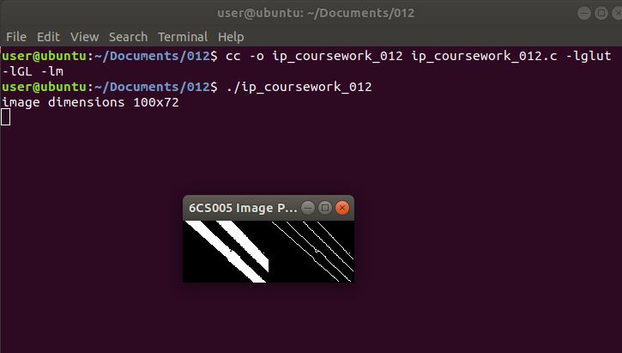

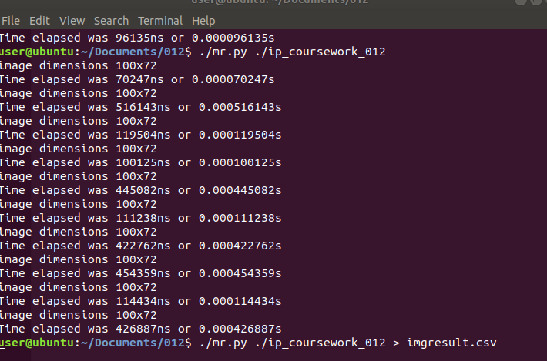

Code of image processing :
#include <stdio.h>
#include <stdlib.h>
#include <time.h>
#include <GL/glut.h>
#include <GL/gl.h>
#include <malloc.h>
#include <signal.h>

#define width 100
#define height 72

unsigned char image[], results[width * height];

void detect_edges(unsigned char *in, unsigned char *out) {
int i;
int n_pixels = width * height;

for(i=0;i<n_pixels;i++) {
int x, y;
int b, d, f, h;
int r;

y = i / width;
x = i - (width * y);

if (x == 0 || y == 0 || x == width - 1 || y == height - 1) {
results[i] = 0;
} else {
b = i + width;
d = i - 1;
f = i + 1;
h = i - width;

r = (in[i] * 4) + (in[b] * -1) + (in[d] * -1) + (in[f] * -1)
+ (in[h] * -1);

if (r > 0) {
out[i] = 255;
} else {
out[i] = 0;
}
}
}
}

void tidy_and_exit() {
exit(0);
}

void sigint_callback(int signal_number){
printf("\nInterrupt from keyboard\n");
tidy_and_exit();
}

static void display() {
glClear(GL_COLOR_BUFFER_BIT);
glRasterPos4i(-1, -1, 0, 1);
glDrawPixels(width, height, GL_LUMINANCE, GL_UNSIGNED_BYTE, image);
glRasterPos4i(0, -1, 0, 1);
glDrawPixels(width, height, GL_LUMINANCE, GL_UNSIGNED_BYTE, results);
glFlush();
}

static void key_pressed(unsigned char key, int x, int y) {
switch(key){
case 27:
tidy_and_exit();
break;
default:
printf("\nPress escape to exit\n");
break;
}
}

int time_difference(struct timespec *start, struct timespec *finish,
long long int *difference) {
long long int ds = finish->tv_sec - start->tv_sec;
long long int dn = finish->tv_nsec - start->tv_nsec;

if(dn < 0 ) {
ds--;
dn += 1000000000;
}
*difference = ds * 1000000000 + dn;
return !(*difference > 0);
}

int main(int argc, char **argv) {
signal(SIGINT, sigint_callback);

printf("image dimensions %dx%d\n", width, height);
struct timespec start, finish;
long long int time_elapsed;
clock_gettime(CLOCK_MONOTONIC,&start);

detect_edges(image, results);

clock_gettime(CLOCK_MONOTONIC, &finish);
time_difference(&start, &finish, &time_elapsed);
printf("Time elapsed was %lldns or %0.9lfs\n", time_elapsed,
(time_elapsed/1.0e9));

glutInit(&argc, argv);
glutInitWindowSize(width * 2,height);
glutInitDisplayMode(GLUT_SINGLE | GLUT_LUMINANCE);

glutCreateWindow("6CS005 Image Progessing Courework");
glutDisplayFunc(display);
glutKeyboardFunc(key_pressed);
glClearColor(0.0, 1.0, 0.0, 1.0);

glutMainLoop();

tidy_and_exit();

return 0;
}

unsigned char image[] = {0,0,0,0,0,0,0,0,0,0,0,0,0,0,0,0,0,0,
0,0,0,0,0,0,0,0,0,0,0,0,0,0,0,0,0,0,0,
0,0,0,0,0,0,0,0,0,0,0,0,0,0,0,0,0,0,0,
0,0,0,0,0,0,0,0,0,0,0,0,0,0,0,0,0,0,0,
0,0,0,0,0,0,0,255,255,255,255,255,255,255,255,255,255,255,255,
255,255,255,0,0,0,0,0,0,0,0,0,0,0,0,0,0,0,0,
0,0,0,0,0,0,0,0,0,0,0,0,0,0,0,0,0,0,0,
0,0,0,0,0,0,0,0,0,0,0,0,0,0,0,0,0,0,0,
0,0,0,0,0,0,0,0,0,0,0,0,0,0,0,0,0,0,0,
0,0,0,0,0,0,0,0,0,0,0,255,255,255,255,255,255,255,255,
255,255,255,255,255,255,255,0,0,0,0,0,0,0,0,0,0,0,0,
0,0,0,0,0,0,0,0,0,0,0,0,0,0,0,0,0,0,0,
0,0,0,0,0,0,0,0,0,0,0,0,0,0,0,0,0,0,0,
0,0,0,0,0,0,0,0,0,0,0,0,0,0,0,0,0,0,0,
0,0,0,0,0,0,0,0,0,0,0,0,0,0,0,255,255,255,255,
255,255,255,255,255,255,255,255,255,255,255,0,0,0,0,0,0,0,0,
0,0,0,0,0,0,0,0,0,0,0,0,0,0,0,0,0,0,0,
0,0,0,0,0,0,0,0,0,0,0,0,0,0,0,0,0,0,0,
0,0,0,0,0,0,0,0,0,0,0,0,0,0,0,0,0,0,0,
0,0,0,0,0,0,0,0,0,0,0,0,0,0,0,0,0,0,0,
255,255,255,255,255,255,255,255,255,255,255,255,255,255,0,0,0,0,0,
0,0,0,0,0,0,0,0,0,0,0,0,0,0,0,0,0,0,0,
0,0,0,0,0,0,0,0,0,0,0,0,0,0,0,0,0,0,0,
0,0,0,0,0,0,0,0,0,0,0,0,0,0,0,0,0,0,0,
0,0,0,0,0,0,0,0,0,0,0,0,0,0,0,0,0,0,0,
0,0,0,0,255,255,255,255,255,255,255,255,255,255,255,255,255,255,0,
0,0,0,0,0,0,0,0,0,0,0,0,0,0,0,0,0,0,0,
0,0,0,0,0,0,0,0,0,0,0,0,0,0,0,0,0,0,0,
0,0,0,0,0,0,0,0,0,0,0,0,0,0,0,0,0,0,0,
0,0,0,0,0,0,0,0,0,0,0,0,0,0,0,0,0,0,0,
0,0,0,0,0,0,0,255,255,255,255,255,255,255,255,255,255,255,255,
255,255,255,255,0,0,0,0,0,0,0,0,0,0,0,0,0,0,0,
0,0,0,0,0,0,0,0,0,0,0,0,0,0,0,0,0,0,0,
0,0,0,0,0,0,0,0,0,0,0,0,0,0,0,0,0,0,0,
0,0,0,0,0,0,0,0,0,0,0,0,0,0,0,0,0,0,0,
0,0,0,0,0,0,0,0,0,0,0,0,255,255,255,255,255,255,255,
255,255,255,255,255,255,255,0,0,0,0,0,0,0,0,0,0,0,0,
0,0,0,0,0,0,0,0,0,0,0,0,0,0,0,0,0,0,0,
0,0,0,0,0,0,0,0,0,0,0,0,0,0,0,0,0,0,0,
0,0,0,0,0,0,0,0,0,0,0,0,0,0,0,0,0,0,0,
0,0,0,0,0,0,0,0,0,0,0,0,0,0,0,255,255,255,255,
255,255,255,255,255,255,255,255,255,255,255,255,0,0,0,0,0,0,0,
0,0,0,0,0,0,0,0,0,0,0,0,0,0,0,0,0,0,0,
0,0,0,0,0,0,0,0,0,0,0,0,0,0,0,0,0,0,0,
0,0,0,0,0,0,0,0,0,0,0,0,0,0,0,0,0,0,0,
0,0,0,0,0,0,0,0,0,0,0,0,0,0,0,0,0,0,0,
255,255,255,255,255,255,255,255,255,255,255,255,255,255,255,0,0,0,0,
0,0,0,0,0,0,0,0,0,0,0,0,0,0,0,0,0,0,0,
0,0,0,0,0,0,0,0,0,0,0,0,0,0,0,0,0,0,0,
0,0,0,0,0,0,0,0,0,0,0,0,0,0,0,0,0,0,0,
0,0,0,0,0,0,0,0,0,0,0,0,0,0,0,0,0,0,0,
0,0,0,0,255,255,255,255,255,255,255,255,255,255,255,255,255,255,255,
0,0,0,0,0,0,0,0,0,0,0,0,0,0,0,0,0,0,0,
0,0,0,0,0,0,0,0,0,0,0,0,0,0,0,0,0,0,0,
0,0,0,0,0,0,0,0,0,0,0,0,0,0,0,0,0,0,0,
0,0,0,0,0,0,0,0,0,0,0,0,0,0,0,0,0,0,0,
0,0,0,0,0,0,0,0,255,255,255,255,255,255,255,255,255,255,255,
255,255,255,255,0,0,0,0,0,0,0,0,0,0,0,0,0,0,0,
0,0,0,0,0,0,0,0,0,0,0,0,0,0,0,0,0,0,0,
0,0,0,0,0,0,0,0,0,0,0,0,0,0,0,0,0,0,0,
0,0,0,0,0,0,0,0,0,0,0,0,0,0,0,0,0,0,0,
0,0,0,0,0,0,0,0,0,0,0,0,255,255,255,255,255,255,255,
255,255,255,255,255,255,255,255,0,0,0,0,0,0,0,0,0,0,0,
0,0,0,0,0,0,0,0,0,0,0,0,0,0,0,0,0,0,0,
0,0,0,0,0,0,0,0,0,0,0,0,0,0,0,0,0,0,0,
0,0,0,0,0,0,0,0,0,0,0,0,0,0,0,0,0,0,0,
0,0,0,0,0,0,0,0,0,0,0,0,0,0,0,0,255,255,255,
255,255,255,255,255,255,255,255,255,255,255,255,0,0,0,0,0,0,0,
0,0,0,0,0,0,0,0,255,0,0,0,0,0,0,0,0,0,0,
0,0,0,0,0,0,0,0,0,0,0,0,0,0,0,0,0,0,0,
0,0,0,0,0,0,0,0,0,0,0,0,0,0,0,0,0,0,0,
0,0,0,0,0,0,0,0,0,0,0,0,0,0,0,0,0,0,0,
0,255,255,255,255,255,255,255,255,255,255,255,255,255,255,255,0,0,0,
0,0,0,0,0,0,0,0,0,0,0,0,255,255,0,0,0,0,0,
0,0,0,0,0,0,0,0,0,0,0,0,0,0,0,0,0,0,0,
0,0,0,0,0,0,0,0,0,0,0,0,0,0,0,0,0,0,0,
0,0,0,0,0,0,0,0,0,0,0,0,0,0,0,0,0,0,0,
0,0,0,0,255,255,255,255,255,255,255,255,255,255,255,255,255,255,255,
255,0,0,0,0,0,0,0,0,0,0,0,0,0,0,0,255,255,255,
0,0,0,0,0,0,0,0,0,0,0,0,0,0,0,0,0,0,0,
0,0,0,0,0,0,0,0,0,0,0,0,0,0,0,0,0,0,0,
0,0,0,0,0,0,0,0,0,0,0,0,0,0,0,0,0,0,0,
0,0,0,0,0,0,0,0,255,255,255,255,255,255,255,255,255,255,255,
255,255,255,255,255,0,0,0,0,0,0,0,0,0,0,0,0,0,0,
0,255,255,255,255,0,0,0,0,0,0,0,0,0,0,0,0,0,0,
0,0,0,0,0,0,0,0,0,0,0,0,0,0,0,0,0,0,0,
0,0,0,0,0,0,0,0,0,0,0,0,0,0,0,0,0,0,0,
0,0,0,0,0,0,0,0,0,0,0,0,255,255,255,255,255,255,255,
255,255,255,255,255,255,255,255,255,0,0,0,0,0,0,0,0,0,0,
0,0,0,0,0,255,255,255,255,255,0,0,0,0,0,0,0,0,0,
0,0,0,0,0,0,0,0,0,0,0,0,0,0,0,0,0,0,0,
0,0,0,0,0,0,0,0,0,0,0,0,0,0,0,0,0,0,0,
0,0,0,0,0,0,0,0,0,0,0,0,0,0,0,0,255,255,255,
255,255,255,255,255,255,255,255,255,255,255,255,255,0,0,0,0,0,0,
0,0,0,0,0,0,0,0,0,255,255,255,255,255,255,0,0,0,0,
0,0,0,0,0,0,0,0,0,0,0,0,0,0,0,0,0,0,0,
0,0,0,0,0,0,0,0,0,0,0,0,0,0,0,0,0,0,0,
0,0,0,0,0,0,0,0,0,0,0,0,0,0,0,0,0,0,0,
255,255,255,255,255,255,255,255,255,255,255,255,255,255,255,255,0,0,0,
0,0,0,0,0,0,0,0,0,0,0,0,0,255,255,255,255,255,255,
255,0,0,0,0,0,0,0,0,0,0,0,0,0,0,0,0,0,0,
0,0,0,0,0,0,0,0,0,0,0,0,0,0,0,0,0,0,0,
0,0,0,0,0,0,0,0,0,0,0,0,0,0,0,0,0,0,0,
0,0,0,0,0,255,255,255,255,255,255,255,255,255,255,255,255,255,255,
255,255,0,0,0,0,0,0,0,0,0,0,0,0,0,0,0,255,255,
255,255,255,255,255,255,0,0,0,0,0,0,0,0,0,0,0,0,0,
0,0,0,0,0,0,0,0,0,0,0,0,0,0,0,0,0,0,0,
0,0,0,0,0,0,0,0,0,0,0,0,0,0,0,0,0,0,0,
0,0,0,0,0,0,0,0,255,255,255,255,255,255,255,255,255,255,255,
255,255,255,255,255,0,0,0,0,0,0,0,0,0,0,0,0,0,0,
0,0,255,255,255,255,255,255,255,255,255,0,0,0,0,0,0,0,0,
0,0,0,0,0,0,0,0,0,0,0,0,0,0,0,0,0,0,0,
0,0,0,0,0,0,0,0,0,0,0,0,0,0,0,0,0,0,0,
0,0,0,0,0,0,0,0,0,0,0,0,255,255,255,255,255,255,255,
255,255,255,255,255,255,255,255,255,0,0,0,0,0,0,0,0,0,0,
0,0,0,0,0,0,255,255,255,255,255,255,255,255,255,255,0,0,0,
0,0,0,0,0,0,0,0,0,0,0,0,0,0,0,0,0,0,0,
0,0,0,0,0,0,0,0,0,0,0,0,0,0,0,0,0,0,0,
0,0,0,0,0,0,0,0,0,0,0,0,0,0,0,0,255,255,255,
255,255,255,255,255,255,255,255,255,255,255,255,255,0,0,0,0,0,0,
0,0,0,0,0,0,0,0,0,0,255,255,255,255,255,255,255,255,255,
255,255,0,0,0,0,0,0,0,0,0,0,0,0,0,0,0,0,0,
0,0,0,0,0,0,0,0,0,0,0,0,0,0,0,0,0,0,0,
0,0,0,0,0,0,0,0,0,0,0,0,0,0,0,0,0,0,0,
0,255,255,255,255,255,255,255,255,255,255,255,255,255,255,255,255,0,0,
0,0,0,0,0,0,0,0,0,0,0,0,0,255,255,255,255,255,255,
255,255,255,255,255,255,255,0,0,0,0,0,0,0,0,0,0,0,0,
0,0,0,0,0,0,0,0,0,0,0,0,0,0,0,0,0,0,0,
0,0,0,0,0,0,0,0,0,0,0,0,0,0,0,0,0,0,0,
0,0,0,0,255,255,255,255,255,255,255,255,255,255,255,255,255,255,255,
255,255,0,0,0,0,0,0,0,0,0,0,0,0,0,0,0,255,255,
255,255,255,255,255,255,255,255,255,255,255,255,0,0,0,0,0,0,0,
0,0,0,0,0,0,0,0,0,0,0,0,0,0,0,0,0,0,0,
0,0,0,0,0,0,0,0,0,0,0,0,0,0,0,0,0,0,0,
0,0,0,0,0,0,0,0,255,255,255,255,255,255,255,255,255,255,255,
255,255,255,255,255,255,0,0,0,0,0,0,0,0,0,0,0,0,0,
0,0,0,255,255,255,255,255,255,255,255,255,255,255,255,255,255,0,0,
0,0,0,0,0,0,0,0,0,0,0,0,0,0,0,0,0,0,0,
0,0,0,0,0,0,0,0,0,0,0,0,0,0,0,0,0,0,0,
0,0,0,0,0,0,0,0,0,0,0,0,0,255,255,255,255,255,255,
255,255,255,255,255,255,255,255,255,255,0,0,0,0,0,0,0,0,0,
0,0,0,0,0,0,0,255,255,255,255,255,255,255,255,255,255,255,255,
255,255,255,0,0,0,0,0,0,0,0,0,0,0,0,0,0,0,0,
0,0,0,0,0,0,0,0,0,0,0,0,0,0,0,0,0,0,0,
0,0,0,0,0,0,0,0,0,0,0,0,0,0,0,0,0,255,255,
255,255,255,255,255,255,255,255,255,255,255,255,255,255,0,0,0,0,0,
0,0,0,0,0,0,0,0,0,0,0,255,255,255,255,255,255,255,255,
255,255,255,255,255,255,255,0,0,0,0,0,0,0,0,0,0,0,0,
0,0,0,0,0,0,0,0,0,0,0,0,0,0,0,0,0,0,0,
0,0,0,0,0,0,0,0,0,0,0,0,0,0,0,0,0,0,0,
0,0,0,255,255,255,255,255,255,255,255,255,255,255,255,255,255,255,0,
0,0,0,0,0,0,0,0,0,0,0,0,0,0,255,255,255,255,255,
255,255,255,255,255,255,255,255,255,255,255,0,0,0,0,0,0,0,0,
0,0,0,0,0,0,0,0,0,0,0,0,0,0,0,0,0,0,0,
0,0,0,0,0,0,0,0,0,0,0,0,0,0,0,0,0,0,0,
0,0,0,0,0,0,0,255,255,255,255,255,255,255,255,255,255,255,255,
255,255,255,255,0,0,0,0,0,0,0,0,0,0,0,0,0,0,255,
255,255,255,255,255,255,255,255,255,255,255,255,255,255,255,0,0,0,0,
0,0,0,0,0,0,0,0,0,0,0,0,0,0,0,0,0,0,0,
0,0,0,0,0,0,0,0,0,0,0,0,0,0,0,0,0,0,0,
0,0,0,0,0,0,0,0,0,0,0,255,255,255,255,255,255,255,255,
255,255,255,255,255,255,255,255,255,0,0,0,0,0,0,0,0,0,0,
0,0,0,0,255,255,255,255,255,255,255,255,255,255,255,255,255,255,255,
0,0,0,0,0,0,0,0,0,0,0,0,0,0,0,0,0,0,0,
0,0,0,0,0,0,0,0,0,0,0,0,0,0,0,0,0,0,0,
0,0,0,0,0,0,0,0,0,0,0,0,0,0,255,255,255,255,255,
255,255,255,255,255,255,255,255,255,255,255,255,0,0,0,0,0,0,0,
0,0,0,0,0,0,0,255,255,255,255,255,255,255,255,255,255,255,255,
255,255,255,255,0,0,0,0,0,0,0,0,0,0,0,0,0,0,0,
0,0,0,0,0,0,0,0,0,0,0,0,0,0,0,0,0,0,0,
0,0,0,0,0,0,0,0,0,0,0,0,0,0,0,0,0,0,255,
255,255,255,255,255,255,255,255,255,255,255,255,255,255,255,255,0,0,0,
0,0,0,0,0,0,0,0,0,0,0,0,255,255,255,255,255,255,255,
255,255,255,255,255,255,255,255,0,0,0,0,0,0,0,0,0,0,0,
0,0,0,0,0,0,0,0,0,0,0,0,0,0,0,0,0,0,0,
0,0,0,0,0,0,0,0,0,0,0,0,0,0,0,0,0,0,0,
0,0,0,255,255,255,255,255,255,255,255,255,255,255,255,255,255,255,255,
255,0,0,0,0,0,0,0,0,0,0,0,0,0,0,255,255,255,255,
255,255,255,255,255,255,255,255,255,255,255,255,0,0,0,0,0,0,0,
0,0,0,0,0,0,0,0,0,0,0,0,0,0,0,0,0,0,0,
0,0,0,0,0,0,0,0,0,0,0,0,0,0,0,0,0,0,0,
0,0,0,0,0,0,0,255,255,255,255,255,255,255,255,255,255,255,255,
255,255,255,255,255,0,0,0,0,0,0,0,0,0,0,0,0,0,0,
255,255,255,255,255,255,255,255,255,255,255,255,255,255,255,255,0,0,255,
0,0,0,0,0,0,0,0,0,0,0,0,0,0,0,0,0,0,0,
0,0,0,0,0,0,0,0,0,0,0,0,0,0,0,0,0,0,0,
0,0,0,0,0,0,0,0,0,0,0,255,255,255,255,255,255,255,255,
255,255,255,255,255,255,255,255,255,0,0,0,0,0,0,0,0,0,0,
0,0,0,0,255,255,255,255,255,255,255,255,255,255,255,255,255,255,255,
255,0,0,0,0,0,0,0,0,0,0,0,0,0,0,0,0,0,0,
0,0,0,0,0,0,0,0,0,0,0,0,0,0,0,0,0,0,0,
0,0,0,0,0,0,0,0,0,0,0,0,0,0,0,255,255,255,255,
255,255,255,255,255,255,255,255,0,0,255,255,255,0,0,0,0,0,0,
0,0,0,0,0,0,0,0,0,255,255,255,255,255,255,255,255,255,255,
255,255,255,255,255,255,0,0,0,0,0,0,0,0,0,0,0,0,0,
0,0,0,0,0,0,0,0,0,0,0,0,0,0,0,0,0,0,0,
0,0,0,0,0,0,0,0,0,0,0,0,0,0,0,0,0,0,255,
255,255,255,255,255,255,255,255,255,255,255,255,255,255,0,255,0,0,0,
0,0,0,0,0,0,0,0,0,0,0,0,255,255,255,255,255,255,255,
255,255,255,255,255,255,255,255,255,255,0,0,0,0,0,0,0,0,0,
0,0,0,0,0,0,0,0,0,0,0,0,0,0,0,0,0,0,0,
0,0,0,0,0,0,0,0,0,0,0,0,0,0,0,0,0,0,0,
0,0,0,255,255,255,255,255,255,255,255,255,255,255,255,255,255,255,255,
0,0,0,0,0,0,0,0,0,0,0,0,0,0,0,0,255,255,255,
255,255,255,255,255,255,255,255,255,255,255,255,255,0,0,0,0,0,0,
0,0,0,0,0,0,0,0,0,0,0,0,0,0,0,0,0,0,0,
0,0,0,0,0,0,0,0,0,0,0,0,0,0,0,0,0,0,0,
0,0,0,0,0,0,0,255,255,255,255,255,255,255,255,255,255,255,255,
255,255,255,0,0,0,0,0,0,0,0,0,0,0,0,0,0,0,0,
0,0,255,255,255,255,255,255,255,255,255,255,255,255,255,255,255,255,0,
0,0,0,0,0,0,0,0,0,0,0,0,0,0,0,0,0,0,0,
0,0,0,0,0,0,0,0,0,0,0,0,0,0,0,0,0,0,0,
0,0,0,0,0,0,0,0,0,0,0,255,255,255,255,255,255,255,255,
255,255,255,255,255,255,255,255,0,0,0,0,0,0,0,0,0,0,0,
0,0,0,0,0,255,255,255,255,255,255,255,255,255,255,255,255,255,255,
255,255,255,0,0,0,0,0,0,0,0,0,0,0,0,0,0,0,0,
0,0,0,0,0,0,0,0,0,0,0,0,0,0,0,0,0,0,0,
0,0,0,0,0,0,0,0,0,0,0,0,0,0,0,255,255,255,255,
255,255,255,255,255,255,255,255,255,255,255,255,0,0,0,0,0,0,0,
0,0,0,0,0,0,0,0,0,0,255,255,255,255,255,255,255,255,255,
255,255,255,255,255,255,255,0,0,0,0,0,0,0,0,0,0,0,0,
0,0,0,0,0,0,0,0,0,0,0,0,0,0,0,0,0,0,0,
0,0,0,0,0,0,0,0,0,0,0,0,0,0,0,0,0,0,0,
255,255,255,255,255,255,255,255,255,255,255,255,255,255,255,255,0,0,0,
0,0,0,0,0,0,0,0,0,0,0,0,0,255,255,255,255,255,255,
255,255,255,255,255,255,255,255,255,255,255,0,0,0,0,0,0,0,0,
0,0,0,0,0,0,0,0,0,0,0,0,0,0,0,0,0,0,0,
0,0,0,0,0,0,0,0,0,0,0,0,0,0,0,0,0,0,0,
0,0,0,0,255,255,255,255,255,255,255,255,255,255,255,255,255,255,255,
0,0,0,0,0,0,0,0,0,0,0,0,0,0,0,0,0,255,255,
255,255,255,255,255,255,255,255,255,255,255,255,255,255,255,0,0,0,0,
0,0,0,0,0,0,0,0,0,0,0,0,0,0,0,0,0,0,0,
0,0,0,0,0,0,0,0,0,0,0,0,0,0,0,0,0,0,0,
0,0,0,0,0,0,0,255,255,255,255,255,255,255,255,255,255,255,255,
255,255,255,255,0,0,0,0,0,0,0,0,0,0,0,0,0,0,0,
0,0,0,255,255,255,255,255,255,255,255,255,255,255,255,255,255,255,255,
0,0,0,0,0,0,0,0,0,0,0,0,0,0,0,0,0,0,0,
0,0,0,0,0,0,0,0,0,0,0,0,0,0,0,0,0,0,0,
0,0,0,0,0,0,0,0,0,0,0,255,255,255,255,255,255,255,255,
255,255,255,255,255,255,255,255,0,0,0,0,0,0,0,0,0,0,0,
0,0,0,0,0,0,0,255,255,255,255,255,255,255,255,255,255,255,255,
255,255,255,255,0,0,0,0,0,0,0,0,0,0,0,0,0,0,0,
0,0,0,0,0,0,0,0,0,0,0,0,0,0,0,0,0,0,0,
0,0,0,0,0,0,0,0,0,0,0,0,0,0,0,255,255,255,255,
255,255,255,255,255,255,255,255,255,255,255,255,0,0,0,0,0,0,0,
0,0,0,0,0,0,0,0,0,0,255,255,255,255,255,255,255,255,255,
255,255,255,255,255,255,255,255,0,0,0,0,0,0,0,0,0,0,0,
0,0,0,0,0,0,0,0,0,0,0,0,0,0,0,0,0,0,0,
0,0,0,0,0,0,0,0,0,0,0,0,0,0,0,0,0,0,0,
255,255,255,255,255,255,255,255,255,255,255,255,255,255,255,255,0,0,0,
0,0,0,0,0,0,0,0,0,0,0,0,0,0,255,255,255,255,255,
255,255,255,255,255,255,255,255,255,255,255,255,0,0,0,0,0,0,0,
0,0,0,0,0,0,0,0,0,0,0,0,0,0,0,0,0,0,0,
0,0,0,0,0,0,0,0,0,0,0,0,0,0,0,0,0,0,0,
0,0,0,0,255,255,255,255,255,255,255,255,255,255,255,255,255,255,255,
255,0,0,0,0,0,0,0,0,0,0,0,0,0,0,0,0,0,255,
255,255,255,255,255,255,255,255,255,255,255,255,255,255,255,255,0,0,0,
0,0,0,0,0,0,0,0,0,0,0,0,0,0,0,0,0,0,0,
0,0,0,0,0,0,0,0,0,0,0,0,0,0,0,0,0,0,0,
0,0,0,0,0,0,0,0,255,255,255,255,255,255,255,255,255,255,255,
255,255,255,255,255,0,0,0,0,0,0,0,0,0,0,0,0,0,0,
0,0,0,0,255,255,255,255,255,255,255,255,255,255,255,255,255,255,255,
255,0,0,0,0,0,0,0,0,0,0,0,0,0,0,0,0,0,0,
0,0,0,0,0,0,0,0,0,0,0,0,0,0,0,0,0,0,0,
0,0,0,0,0,0,0,0,0,0,0,0,255,255,255,255,255,255,255,
255,255,255,255,255,255,255,255,255,0,0,0,0,0,0,0,0,0,0,
0,0,0,0,0,0,0,255,255,255,255,255,255,255,255,255,255,255,255,
255,255,255,255,255,0,0,0,0,0,0,0,0,0,0,0,0,0,0,
0,0,0,0,0,0,0,0,0,0,0,0,0,0,0,0,0,0,0,
0,0,0,0,0,0,0,0,0,0,0,0,0,0,0,0,255,255,255,
255,255,255,255,255,255,255,255,255,255,255,255,255,0,0,0,0,0,0,
0,0,0,0,0,0,0,0,0,0,0,255,255,255,255,255,255,255,255,
255,255,255,255,255,255,255,255,255,0,0,0,0,0,0,0,0,0,0,
0,0,0,0,0,0,0,0,0,0,0,0,0,0,0,0,0,0,0,
0,0,0,0,0,0,0,0,0,0,0,0,0,0,0,0,0,0,0,
255,255,255,255,255,255,255,255,255,255,255,255,255,255,255,255,255,0,0,
0,0,0,0,0,0,0,0,0,0,0,0,0,0,0,0,255,255,255,
255,255,255,255,255,255,255,255,255,255,255,255,255,255,0,0,0,0,0,
0,0,0,0,0,0,0,0,0,0,0,0,0,0,0,0,0,0,0,
0,0,0,0,0,0,0,0,0,0,0,0,0,0,0,0,0,0,0,
0,0,0,0,255,255,255,255,255,255,255,255,255,255,255,255,255,255,255,
255,255,0,0,0,0,0,0,0,0,0,0,0,0,0,0,0,0,0,
255,255,255,255,255,255,255,255,255,255,255,255,255,255,255,255,255,0,0,
0,0,0,0,0,0,0,0,0,0,0,0,0,0,0,0,0,0,0,
0,0,0,0,0,0,0,0,0,0,0,0,0,0,0,0,0,0,0,
0,0,0,0,0,0,0,0,255,255,255,255,255,255,255,255,255,255,255,
255,255,255,255,255,0,0,0,0,0,0,0,0,0,0,0,0,0,0,
0,0,0,0,255,255,255,255,255,255,255,255,255,255,255,255,255,255,255,
255,255,255,0,0,0,0,0,0,0,0,0,0,0,0,0,0,0,0,
0,0,0,0,0,0,0,0,0,0,0,0,0,0,0,0,0,0,0,
0,0,0,0,0,0,0,0,0,0,0,0,255,255,255,255,255,255,255,
255,255,255,255,255,255,255,255,255,0,0,0,0,0,0,0,0,0,0,
0,0,0,0,0,0,0,0,255,255,255,255,255,255,255,255,255,255,255,
255,255,255,255,255,255,255,0,0,0,0,0,0,0,0,0,0,0,0,
0,0,0,0,0,0,0,0,0,0,0,0,0,0,0,0,0,0,0,
0,0,0,0,0,0,0,0,0,0,0,0,0,0,0,0,255,255,255,
255,255,255,255,255,255,255,255,255,255,255,255,255,0,0,0,0,0,0,
0,0,0,0,0,0,0,0,0,0,0,0,255,255,255,255,255,255,255,
255,255,255,255,255,255,255,255,255,255,0,0,0,0,0,0,0,0,0,
0,0,0,0,0,0,0,0,0,0,0,0,0,0,0,0,0,0,0,
0,0,0,0,0,0,0,0,0,0,0,0,0,0,0,0,0,0,0,
0,255,255,255,255,255,255,255,255,255,255,255,255,255,255,255,255,0,0,
0,0,0,0,0,0,0,0,0,0,0,0,0,0,0,0,255,255,255,
255,255,255,255,255,255,255,255,255,255,255,255,255,255,255,0,0,0,0,
0,0,0,0,0,0,0,0,0,0,0,0,0,0,0,0,0,0,0,
0,0,0,0,0,0,0,0,0,0,0,0,0,0,0,0,0,0,0,
0,0,0,0,0,255,255,255,255,255,255,255,255,255,255,255,255,255,255,
255,255,0,0,0,0,0,0,0,0,0,0,0,0,0,0,0,0,0,
0,255,255,255,255,255,255,255,255,255,255,255,255,255,255,255,255,255,255,
0,0,0,0,0,0,0,0,0,0,0,0,0,0,0,0,0,0,0,
0,0,0,0,0,0,0,0,0,0,0,0,0,0,0,0,0,0,0,
0,0,0,0,0,0,0,0,0,255,255,255,255,255,255,255,255,255,255,
255,255,255,255,255,255,0,0,0,0,0,0,0,0,0,0,0,0,0,
0,0,0,0,0,0,255,255,255,255,255,255,255,255,255,255,255,255,255,
255,255,255,255,0,0,0,0,0,0,0,0,0,0,0,0,0,0,0,
0,0,0,0,0,0,0,0,0,0,0,0,0,0,0,0,0,0,0,
0,0,0,0,0,0,0,0,0,0,0,0,255,255,255,255,255,255,255,
255,255,255,255,255,255,255,255,255,255,0,0,0,0,0,0,0,0,0,
0,0,0,0,0,0,0,0,0,255,255,255,255,255,255,255,255,255,255,
255,255,255,255,255,255,255,255,0,0,0,0,0,0,0,0,0,0,0,
0,0,0,0,0,0,0,0,0,0,0,0,0,0,0,0,0,0,0,
0,0,0,0,0,0,0,0,0,0,0,0,0,0,0,0,255,255,255,
255,255,255,255,255,255,255,255,255,255,255,255,255,255,0,0,0,0,0,
0,0,0,0,0,0,0,0,0,0,0,0,0,255,255,255,255,255,255,
255,255,255,255,255,255,255,255,255,255,255,255,0,0,0,0,0,0,0,
0,0,0,0,0,0,0,0,0,0,0,0,0,0,0,0,0,0,0,
0,0,0,0,0,0,0,0,0,0,0,0,0,0,0,0,0,0,0,
0,255,255,255,255,255,255,255,255,255,255,255,255,255,255,255,255,255,0,
0,0,0,0,0,0,0,0,0,0,0,0,0,0,0,0,0,255,255,
255,255,255,255,255,255,255,255,255,255,255,255,255,255,255,255,0,0,0,
0,0,0,0,0,0,0,0,0,0,0,0,0,0,0,0,0,0,0,
0,0,0,0,0,0,0,0,0,0,0,0,0,0,0,0,0,0,0,
0,0,0,0,0,255,255,255,255,255,255,255,255,255,255,255,255,255,255,
255,255,255,0,0,0,0,0,0,0,0,0,0,0,0,0,0,0,0,
0,0,255,255,255,255,255,255,255,255,255,255,255,255,255,255,255,255,255,
255,0,0,0,0,0,0,0,0,0,0,0,0,0,0,0,0,0,0,
0,0,0,0,0,0,0,0,0,0,0,0,0,0,0,0,0,0,0,
0,0,0,0,0,0,0,0,0,255,255,255,255,255,255,255,255,255,255,
255,255,255,255,255,255,255,0,0,0,0,0,0,0,0,0,0,0,0,
0,0,0,0,0,0,255,255,255,255,255,255,255,255,255,255,255,255,255,
255,255,255,255,255,0,0,0,0,0,0,0,0,0,0,0,0,0,0,
0,0,0,0,0,0,0,0,0,0,0,0,0,0,0,0,0,0,0,
0,0,0,0,0,0,0,0,0,0,0,0,0,255,255,255,255,255,255,
255,255,255,255,255,255,255,255,255,255,255,0,0,0,0,0,0,0,0,
0,0,0,0,0,0,0,0,0,0,255,255,255,255,255,255,255,255,255,
255,255,255,255,255,255,255,255,255,0,0,0,0,0,0,0,0,0,0,
0,0,0,0,0,0,0,0,0,0,0,0,0,0,0,0,0,0,0,
0,0,0,0,0,0,0,0,0,0,0,0,0,0,0,0,0,255,255,
255,255,255,255,255,255,255,255,255,255,255,255,255,255,255,0,0,0,0,
0,0,0,0,0,0,0,0,0,0,0,0,0,0,0,255,255,255,255,
255,255,255,255,255,255,255,255,255,255,255,255,255,0,0,0,0,0,0,
0,0,0,0,0,0,0,0,0,0,0,0,0,0,0,0,0,0,0,
0,0,0,0,0,0,0,0,0,0,0,0,0,0,0,0,0,0,0,
0,255,255,255,255,255,255,255,255,255,255,255,255,255,255,255,255,255,255,
0,0,0,0,0,0,0,0,0,0,0,0,0,0,0,0,0,0,255,
255,255,255,255,255,255,255,255,255,255,255,255,255,255,255,255,255,0,0,
0,0,0,0,0,0,0,0,0,0,0,0,0,0,0,0,0,0,0,
0,0,0,0,0,0,0,0,0,0,0,0,0,0,0,0,0,0,0,
0,0,0,0,0,255,255,255,255,255,255,255,255,255,255,255,255,255,255,
255,255,255,255,0,0,0,0,0,0,0,0,0,0,0,0,0,0,0,
0,0,0,255,255,255,255,255,255,255,255,255,255,255,255,255,255,255,255,
255,255,0,0,0,0,0,0,0,0,0,0,0,0,0,0,0,0,0,
0,0,0,0,0,0,0,0,0,0,0,0,0,0,0,0,0,0,0,
0,0,0,0,0,0,0,0,0,255,255,255,255,255,255,255,255,255,255,
255,255,255,255,255,255,255,255,0,0,0,0,0,0,0,0,0,0,0,
0,0,0,0,0,0,0,0,255,255,255,255,255,255,255,255,255,255,255,
255,255,255,255,255,255,0,0,0,0,0,0,0,0,0,0,0,0,0,
0,0,0,0,0,0,0,0,0,0,0,0,0,0,0,0,0,0,0,
0,0,0,0,0,0,0,0,0,0,0,0,0,255,255,255,255,255,255,
255,255,255,255,255,255,255,255,255,255,255,255,0,0,0,0,0,0,0,
0,0,0,0,0,0,0,0,0,0,0,255,255,255,255,255,255,255,255,
255,255,255,255,255,255,255,255,255,255,0,0,0,0,0,0,0,0,0,
0,0,0,0,0,0,0,0,0,0,0,0,0,0,0,0,0,0,0,
0,0,0,0,0,0,0,0,0,0,0,0,0,0,0,0,0,255,255,
255,255,255,255,255,255,255,255,255,255,255,255,255,255,255,255,0,0,0,
0,0,0,0,0,0,0,0,0,0,0,0,0,0,0,255,255,255,255,
255,255,255,255,255,255,255,255,255,255,255,255,255,255,0,0,0,0,0,
0,0,0,0,0,0,0,0,0,0,0,0,0,0,0,0,0,0,0,
0,0,0,0,0,0,0,0,0,0,0,0,0,0,0,0,0,0,0
};

- Implement a version of the edge detector that can process 4 pixels in parallel. It should do this by using a striding technique, i.e. each thread processes every fourth pixel as shown in the small image below. The first thread processes the blue/purple pixels, the second processes the cyan ones, the third thread processes the yellow ones and the fourth thread processes the red ones.
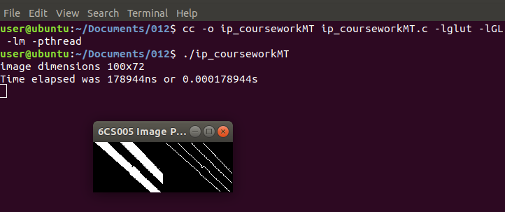

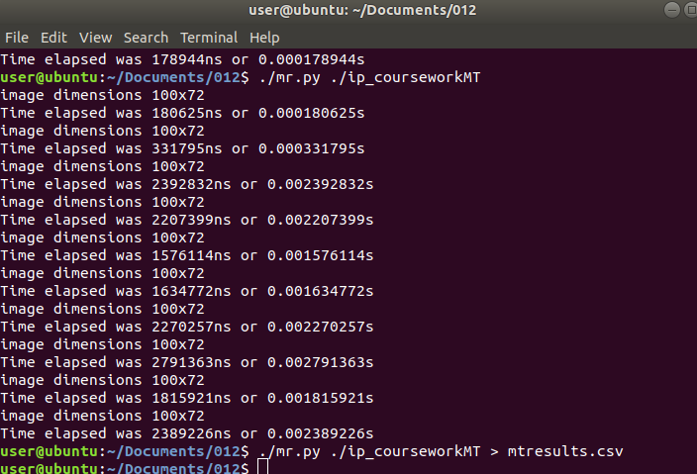

Multithread Program Code
#include <stdio.h>
#include <stdlib.h>
#include <time.h>
#include <GL/glut.h>
#include <GL/gl.h>
#include <malloc.h>
#include <signal.h>
#include <pthread.h>

#define width 100
#define height 72

unsigned char image[], results[width * height];

typedef struct arg_t{
int stride;
int start;
} mt_thread;

void detect_edges(unsigned char *in, unsigned char *out, mt_thread *args) {
int i;
int n_pixels = width * height;

for(i=args->start;i<n_pixels;i+=args->stride) {
int x, y;
int b, d, f, h;
int r;

y = i / width;
x = i - (width * y);

if (x == 0 || y == 0 || x == width - 1 || y == height - 1) {
results[i] = 0;
} else {
b = i + width;
d = i - 1;
f = i + 1;
h = i - width;

r = (in[i] * 4) + (in[b] * -1) + (in[d] * -1) + (in[f] * -1)
+ (in[h] * -1);

if (r > 0) {
out[i] = 255;
} else {
out[i] = 0;
}
}
}
}

void *detect(void *args){
detect_edges(image,results,args);
}

void tidy_and_exit() {
exit(0);
}

void sigint_callback(int signal_number){
printf("\nInterrupt from keyboard\n");
tidy_and_exit();
}

static void display() {
glClear(GL_COLOR_BUFFER_BIT);
glRasterPos4i(-1, -1, 0, 1);
glDrawPixels(width, height, GL_LUMINANCE, GL_UNSIGNED_BYTE, image);
glRasterPos4i(0, -1, 0, 1);
glDrawPixels(width, height, GL_LUMINANCE, GL_UNSIGNED_BYTE, results);
glFlush();
}

static void key_pressed(unsigned char key, int x, int y) {
switch(key){
case 27:
tidy_and_exit();
break;
default:
printf("\nPress escape to exit\n");
break;
}
}

int time_difference(struct timespec *start, struct timespec *finish,
long long int *difference) {
long long int ds = finish->tv_sec - start->tv_sec;
long long int dn = finish->tv_nsec - start->tv_nsec;

if(dn < 0 ) {
ds--;
dn += 1000000000;
}
*difference = ds * 1000000000 + dn;
return !(*difference > 0);
}

int main(int argc, char **argv) {

struct timespec start, finish;
long long int time_elapsed;
clock_gettime(CLOCK_MONOTONIC, &start);

signal(SIGINT, sigint_callback);

printf("image dimensions %dx%d\n", width, height);
//detect_edges(image, results);

pthread_t MT1,MT2,MT3,MT4;
mt_thread MT1_arguments;
MT1_arguments.start = 0;
MT1_arguments.stride = 4;

mt_thread MT2_arguments;
MT2_arguments.start = 1;
MT2_arguments.stride = 4;

mt_thread MT3_arguments;
MT3_arguments.start = 2;
MT3_arguments.stride = 4;

mt_thread MT4_arguments;
MT4_arguments.start = 3;
MT4_arguments.stride = 4;

pthread_create(&MT1, NULL, detect, &MT1_arguments);
pthread_create(&MT2, NULL, detect, &MT2_arguments);
pthread_create(&MT3, NULL, detect, &MT3_arguments);
pthread_create(&MT4, NULL, detect, &MT4_arguments);

pthread_join(MT1, NULL);
pthread_join(MT2, NULL);
pthread_join(MT3, NULL);
pthread_join(MT4, NULL);

clock_gettime(CLOCK_MONOTONIC, &finish);
time_difference(&start, &finish, &time_elapsed);
printf("Time elapsed was %lldns or %0.9lfs\n", time_elapsed,
(time_elapsed/1.0e9));

glutInit(&argc, argv);
glutInitWindowSize(width * 2,height);
glutInitDisplayMode(GLUT_SINGLE | GLUT_LUMINANCE);

glutCreateWindow("6CS005 Image Progessing Courework");
glutDisplayFunc(display);
glutKeyboardFunc(key_pressed);
glClearColor(0.0, 1.0, 0.0, 1.0);

glutMainLoop();

tidy_and_exit();

return 0;
}

unsigned char image[] = {0,0,0,0,0,0,0,0,0,0,0,0,0,0,0,0,0,0,
0,0,0,0,0,0,0,0,0,0,0,0,0,0,0,0,0,0,0,
0,0,0,0,0,0,0,0,0,0,0,0,0,0,0,0,0,0,0,
0,0,0,0,0,0,0,0,0,0,0,0,0,0,0,0,0,0,0,
0,0,0,0,0,0,0,255,255,255,255,255,255,255,255,255,255,255,255,
255,255,255,0,0,0,0,0,0,0,0,0,0,0,0,0,0,0,0,
0,0,0,0,0,0,0,0,0,0,0,0,0,0,0,0,0,0,0,
0,0,0,0,0,0,0,0,0,0,0,0,0,0,0,0,0,0,0,
0,0,0,0,0,0,0,0,0,0,0,0,0,0,0,0,0,0,0,
0,0,0,0,0,0,0,0,0,0,0,255,255,255,255,255,255,255,255,
255,255,255,255,255,255,255,0,0,0,0,0,0,0,0,0,0,0,0,
0,0,0,0,0,0,0,0,0,0,0,0,0,0,0,0,0,0,0,
0,0,0,0,0,0,0,0,0,0,0,0,0,0,0,0,0,0,0,
0,0,0,0,0,0,0,0,0,0,0,0,0,0,0,0,0,0,0,
0,0,0,0,0,0,0,0,0,0,0,0,0,0,0,255,255,255,255,
255,255,255,255,255,255,255,255,255,255,255,0,0,0,0,0,0,0,0,
0,0,0,0,0,0,0,0,0,0,0,0,0,0,0,0,0,0,0,
0,0,0,0,0,0,0,0,0,0,0,0,0,0,0,0,0,0,0,
0,0,0,0,0,0,0,0,0,0,0,0,0,0,0,0,0,0,0,
0,0,0,0,0,0,0,0,0,0,0,0,0,0,0,0,0,0,0,
255,255,255,255,255,255,255,255,255,255,255,255,255,255,0,0,0,0,0,
0,0,0,0,0,0,0,0,0,0,0,0,0,0,0,0,0,0,0,
0,0,0,0,0,0,0,0,0,0,0,0,0,0,0,0,0,0,0,
0,0,0,0,0,0,0,0,0,0,0,0,0,0,0,0,0,0,0,
0,0,0,0,0,0,0,0,0,0,0,0,0,0,0,0,0,0,0,
0,0,0,0,255,255,255,255,255,255,255,255,255,255,255,255,255,255,0,
0,0,0,0,0,0,0,0,0,0,0,0,0,0,0,0,0,0,0,
0,0,0,0,0,0,0,0,0,0,0,0,0,0,0,0,0,0,0,
0,0,0,0,0,0,0,0,0,0,0,0,0,0,0,0,0,0,0,
0,0,0,0,0,0,0,0,0,0,0,0,0,0,0,0,0,0,0,
0,0,0,0,0,0,0,255,255,255,255,255,255,255,255,255,255,255,255,
255,255,255,255,0,0,0,0,0,0,0,0,0,0,0,0,0,0,0,
0,0,0,0,0,0,0,0,0,0,0,0,0,0,0,0,0,0,0,
0,0,0,0,0,0,0,0,0,0,0,0,0,0,0,0,0,0,0,
0,0,0,0,0,0,0,0,0,0,0,0,0,0,0,0,0,0,0,
0,0,0,0,0,0,0,0,0,0,0,0,255,255,255,255,255,255,255,
255,255,255,255,255,255,255,0,0,0,0,0,0,0,0,0,0,0,0,
0,0,0,0,0,0,0,0,0,0,0,0,0,0,0,0,0,0,0,
0,0,0,0,0,0,0,0,0,0,0,0,0,0,0,0,0,0,0,
0,0,0,0,0,0,0,0,0,0,0,0,0,0,0,0,0,0,0,
0,0,0,0,0,0,0,0,0,0,0,0,0,0,0,255,255,255,255,
255,255,255,255,255,255,255,255,255,255,255,255,0,0,0,0,0,0,0,
0,0,0,0,0,0,0,0,0,0,0,0,0,0,0,0,0,0,0,
0,0,0,0,0,0,0,0,0,0,0,0,0,0,0,0,0,0,0,
0,0,0,0,0,0,0,0,0,0,0,0,0,0,0,0,0,0,0,
0,0,0,0,0,0,0,0,0,0,0,0,0,0,0,0,0,0,0,
255,255,255,255,255,255,255,255,255,255,255,255,255,255,255,0,0,0,0,
0,0,0,0,0,0,0,0,0,0,0,0,0,0,0,0,0,0,0,
0,0,0,0,0,0,0,0,0,0,0,0,0,0,0,0,0,0,0,
0,0,0,0,0,0,0,0,0,0,0,0,0,0,0,0,0,0,0,
0,0,0,0,0,0,0,0,0,0,0,0,0,0,0,0,0,0,0,
0,0,0,0,255,255,255,255,255,255,255,255,255,255,255,255,255,255,255,
0,0,0,0,0,0,0,0,0,0,0,0,0,0,0,0,0,0,0,
0,0,0,0,0,0,0,0,0,0,0,0,0,0,0,0,0,0,0,
0,0,0,0,0,0,0,0,0,0,0,0,0,0,0,0,0,0,0,
0,0,0,0,0,0,0,0,0,0,0,0,0,0,0,0,0,0,0,
0,0,0,0,0,0,0,0,255,255,255,255,255,255,255,255,255,255,255,
255,255,255,255,0,0,0,0,0,0,0,0,0,0,0,0,0,0,0,
0,0,0,0,0,0,0,0,0,0,0,0,0,0,0,0,0,0,0,
0,0,0,0,0,0,0,0,0,0,0,0,0,0,0,0,0,0,0,
0,0,0,0,0,0,0,0,0,0,0,0,0,0,0,0,0,0,0,
0,0,0,0,0,0,0,0,0,0,0,0,255,255,255,255,255,255,255,
255,255,255,255,255,255,255,255,0,0,0,0,0,0,0,0,0,0,0,
0,0,0,0,0,0,0,0,0,0,0,0,0,0,0,0,0,0,0,
0,0,0,0,0,0,0,0,0,0,0,0,0,0,0,0,0,0,0,
0,0,0,0,0,0,0,0,0,0,0,0,0,0,0,0,0,0,0,
0,0,0,0,0,0,0,0,0,0,0,0,0,0,0,0,255,255,255,
255,255,255,255,255,255,255,255,255,255,255,255,0,0,0,0,0,0,0,
0,0,0,0,0,0,0,0,255,0,0,0,0,0,0,0,0,0,0,
0,0,0,0,0,0,0,0,0,0,0,0,0,0,0,0,0,0,0,
0,0,0,0,0,0,0,0,0,0,0,0,0,0,0,0,0,0,0,
0,0,0,0,0,0,0,0,0,0,0,0,0,0,0,0,0,0,0,
0,255,255,255,255,255,255,255,255,255,255,255,255,255,255,255,0,0,0,
0,0,0,0,0,0,0,0,0,0,0,0,255,255,0,0,0,0,0,
0,0,0,0,0,0,0,0,0,0,0,0,0,0,0,0,0,0,0,
0,0,0,0,0,0,0,0,0,0,0,0,0,0,0,0,0,0,0,
0,0,0,0,0,0,0,0,0,0,0,0,0,0,0,0,0,0,0,
0,0,0,0,255,255,255,255,255,255,255,255,255,255,255,255,255,255,255,
255,0,0,0,0,0,0,0,0,0,0,0,0,0,0,0,255,255,255,
0,0,0,0,0,0,0,0,0,0,0,0,0,0,0,0,0,0,0,
0,0,0,0,0,0,0,0,0,0,0,0,0,0,0,0,0,0,0,
0,0,0,0,0,0,0,0,0,0,0,0,0,0,0,0,0,0,0,
0,0,0,0,0,0,0,0,255,255,255,255,255,255,255,255,255,255,255,
255,255,255,255,255,0,0,0,0,0,0,0,0,0,0,0,0,0,0,
0,255,255,255,255,0,0,0,0,0,0,0,0,0,0,0,0,0,0,
0,0,0,0,0,0,0,0,0,0,0,0,0,0,0,0,0,0,0,
0,0,0,0,0,0,0,0,0,0,0,0,0,0,0,0,0,0,0,
0,0,0,0,0,0,0,0,0,0,0,0,255,255,255,255,255,255,255,
255,255,255,255,255,255,255,255,255,0,0,0,0,0,0,0,0,0,0,
0,0,0,0,0,255,255,255,255,255,0,0,0,0,0,0,0,0,0,
0,0,0,0,0,0,0,0,0,0,0,0,0,0,0,0,0,0,0,
0,0,0,0,0,0,0,0,0,0,0,0,0,0,0,0,0,0,0,
0,0,0,0,0,0,0,0,0,0,0,0,0,0,0,0,255,255,255,
255,255,255,255,255,255,255,255,255,255,255,255,255,0,0,0,0,0,0,
0,0,0,0,0,0,0,0,0,255,255,255,255,255,255,0,0,0,0,
0,0,0,0,0,0,0,0,0,0,0,0,0,0,0,0,0,0,0,
0,0,0,0,0,0,0,0,0,0,0,0,0,0,0,0,0,0,0,
0,0,0,0,0,0,0,0,0,0,0,0,0,0,0,0,0,0,0,
255,255,255,255,255,255,255,255,255,255,255,255,255,255,255,255,0,0,0,
0,0,0,0,0,0,0,0,0,0,0,0,0,255,255,255,255,255,255,
255,0,0,0,0,0,0,0,0,0,0,0,0,0,0,0,0,0,0,
0,0,0,0,0,0,0,0,0,0,0,0,0,0,0,0,0,0,0,
0,0,0,0,0,0,0,0,0,0,0,0,0,0,0,0,0,0,0,
0,0,0,0,0,255,255,255,255,255,255,255,255,255,255,255,255,255,255,
255,255,0,0,0,0,0,0,0,0,0,0,0,0,0,0,0,255,255,
255,255,255,255,255,255,0,0,0,0,0,0,0,0,0,0,0,0,0,
0,0,0,0,0,0,0,0,0,0,0,0,0,0,0,0,0,0,0,
0,0,0,0,0,0,0,0,0,0,0,0,0,0,0,0,0,0,0,
0,0,0,0,0,0,0,0,255,255,255,255,255,255,255,255,255,255,255,
255,255,255,255,255,0,0,0,0,0,0,0,0,0,0,0,0,0,0,
0,0,255,255,255,255,255,255,255,255,255,0,0,0,0,0,0,0,0,
0,0,0,0,0,0,0,0,0,0,0,0,0,0,0,0,0,0,0,
0,0,0,0,0,0,0,0,0,0,0,0,0,0,0,0,0,0,0,
0,0,0,0,0,0,0,0,0,0,0,0,255,255,255,255,255,255,255,
255,255,255,255,255,255,255,255,255,0,0,0,0,0,0,0,0,0,0,
0,0,0,0,0,0,255,255,255,255,255,255,255,255,255,255,0,0,0,
0,0,0,0,0,0,0,0,0,0,0,0,0,0,0,0,0,0,0,
0,0,0,0,0,0,0,0,0,0,0,0,0,0,0,0,0,0,0,
0,0,0,0,0,0,0,0,0,0,0,0,0,0,0,0,255,255,255,
255,255,255,255,255,255,255,255,255,255,255,255,255,0,0,0,0,0,0,
0,0,0,0,0,0,0,0,0,0,255,255,255,255,255,255,255,255,255,
255,255,0,0,0,0,0,0,0,0,0,0,0,0,0,0,0,0,0,
0,0,0,0,0,0,0,0,0,0,0,0,0,0,0,0,0,0,0,
0,0,0,0,0,0,0,0,0,0,0,0,0,0,0,0,0,0,0,
0,255,255,255,255,255,255,255,255,255,255,255,255,255,255,255,255,0,0,
0,0,0,0,0,0,0,0,0,0,0,0,0,255,255,255,255,255,255,
255,255,255,255,255,255,255,0,0,0,0,0,0,0,0,0,0,0,0,
0,0,0,0,0,0,0,0,0,0,0,0,0,0,0,0,0,0,0,
0,0,0,0,0,0,0,0,0,0,0,0,0,0,0,0,0,0,0,
0,0,0,0,255,255,255,255,255,255,255,255,255,255,255,255,255,255,255,
255,255,0,0,0,0,0,0,0,0,0,0,0,0,0,0,0,255,255,
255,255,255,255,255,255,255,255,255,255,255,255,0,0,0,0,0,0,0,
0,0,0,0,0,0,0,0,0,0,0,0,0,0,0,0,0,0,0,
0,0,0,0,0,0,0,0,0,0,0,0,0,0,0,0,0,0,0,
0,0,0,0,0,0,0,0,255,255,255,255,255,255,255,255,255,255,255,
255,255,255,255,255,255,0,0,0,0,0,0,0,0,0,0,0,0,0,
0,0,0,255,255,255,255,255,255,255,255,255,255,255,255,255,255,0,0,
0,0,0,0,0,0,0,0,0,0,0,0,0,0,0,0,0,0,0,
0,0,0,0,0,0,0,0,0,0,0,0,0,0,0,0,0,0,0,
0,0,0,0,0,0,0,0,0,0,0,0,0,255,255,255,255,255,255,
255,255,255,255,255,255,255,255,255,255,0,0,0,0,0,0,0,0,0,
0,0,0,0,0,0,0,255,255,255,255,255,255,255,255,255,255,255,255,
255,255,255,0,0,0,0,0,0,0,0,0,0,0,0,0,0,0,0,
0,0,0,0,0,0,0,0,0,0,0,0,0,0,0,0,0,0,0,
0,0,0,0,0,0,0,0,0,0,0,0,0,0,0,0,0,255,255,
255,255,255,255,255,255,255,255,255,255,255,255,255,255,0,0,0,0,0,
0,0,0,0,0,0,0,0,0,0,0,255,255,255,255,255,255,255,255,
255,255,255,255,255,255,255,0,0,0,0,0,0,0,0,0,0,0,0,
0,0,0,0,0,0,0,0,0,0,0,0,0,0,0,0,0,0,0,
0,0,0,0,0,0,0,0,0,0,0,0,0,0,0,0,0,0,0,
0,0,0,255,255,255,255,255,255,255,255,255,255,255,255,255,255,255,0,
0,0,0,0,0,0,0,0,0,0,0,0,0,0,255,255,255,255,255,
255,255,255,255,255,255,255,255,255,255,255,0,0,0,0,0,0,0,0,
0,0,0,0,0,0,0,0,0,0,0,0,0,0,0,0,0,0,0,
0,0,0,0,0,0,0,0,0,0,0,0,0,0,0,0,0,0,0,
0,0,0,0,0,0,0,255,255,255,255,255,255,255,255,255,255,255,255,
255,255,255,255,0,0,0,0,0,0,0,0,0,0,0,0,0,0,255,
255,255,255,255,255,255,255,255,255,255,255,255,255,255,255,0,0,0,0,
0,0,0,0,0,0,0,0,0,0,0,0,0,0,0,0,0,0,0,
0,0,0,0,0,0,0,0,0,0,0,0,0,0,0,0,0,0,0,
0,0,0,0,0,0,0,0,0,0,0,255,255,255,255,255,255,255,255,
255,255,255,255,255,255,255,255,255,0,0,0,0,0,0,0,0,0,0,
0,0,0,0,255,255,255,255,255,255,255,255,255,255,255,255,255,255,255,
0,0,0,0,0,0,0,0,0,0,0,0,0,0,0,0,0,0,0,
0,0,0,0,0,0,0,0,0,0,0,0,0,0,0,0,0,0,0,
0,0,0,0,0,0,0,0,0,0,0,0,0,0,255,255,255,255,255,
255,255,255,255,255,255,255,255,255,255,255,255,0,0,0,0,0,0,0,
0,0,0,0,0,0,0,255,255,255,255,255,255,255,255,255,255,255,255,
255,255,255,255,0,0,0,0,0,0,0,0,0,0,0,0,0,0,0,
0,0,0,0,0,0,0,0,0,0,0,0,0,0,0,0,0,0,0,
0,0,0,0,0,0,0,0,0,0,0,0,0,0,0,0,0,0,255,
255,255,255,255,255,255,255,255,255,255,255,255,255,255,255,255,0,0,0,
0,0,0,0,0,0,0,0,0,0,0,0,255,255,255,255,255,255,255,
255,255,255,255,255,255,255,255,0,0,0,0,0,0,0,0,0,0,0,
0,0,0,0,0,0,0,0,0,0,0,0,0,0,0,0,0,0,0,
0,0,0,0,0,0,0,0,0,0,0,0,0,0,0,0,0,0,0,
0,0,0,255,255,255,255,255,255,255,255,255,255,255,255,255,255,255,255,
255,0,0,0,0,0,0,0,0,0,0,0,0,0,0,255,255,255,255,
255,255,255,255,255,255,255,255,255,255,255,255,0,0,0,0,0,0,0,
0,0,0,0,0,0,0,0,0,0,0,0,0,0,0,0,0,0,0,
0,0,0,0,0,0,0,0,0,0,0,0,0,0,0,0,0,0,0,
0,0,0,0,0,0,0,255,255,255,255,255,255,255,255,255,255,255,255,
255,255,255,255,255,0,0,0,0,0,0,0,0,0,0,0,0,0,0,
255,255,255,255,255,255,255,255,255,255,255,255,255,255,255,255,0,0,255,
0,0,0,0,0,0,0,0,0,0,0,0,0,0,0,0,0,0,0,
0,0,0,0,0,0,0,0,0,0,0,0,0,0,0,0,0,0,0,
0,0,0,0,0,0,0,0,0,0,0,255,255,255,255,255,255,255,255,
255,255,255,255,255,255,255,255,255,0,0,0,0,0,0,0,0,0,0,
0,0,0,0,255,255,255,255,255,255,255,255,255,255,255,255,255,255,255,
255,0,0,0,0,0,0,0,0,0,0,0,0,0,0,0,0,0,0,
0,0,0,0,0,0,0,0,0,0,0,0,0,0,0,0,0,0,0,
0,0,0,0,0,0,0,0,0,0,0,0,0,0,0,255,255,255,255,
255,255,255,255,255,255,255,255,0,0,255,255,255,0,0,0,0,0,0,
0,0,0,0,0,0,0,0,0,255,255,255,255,255,255,255,255,255,255,
255,255,255,255,255,255,0,0,0,0,0,0,0,0,0,0,0,0,0,
0,0,0,0,0,0,0,0,0,0,0,0,0,0,0,0,0,0,0,
0,0,0,0,0,0,0,0,0,0,0,0,0,0,0,0,0,0,255,
255,255,255,255,255,255,255,255,255,255,255,255,255,255,0,255,0,0,0,
0,0,0,0,0,0,0,0,0,0,0,0,255,255,255,255,255,255,255,
255,255,255,255,255,255,255,255,255,255,0,0,0,0,0,0,0,0,0,
0,0,0,0,0,0,0,0,0,0,0,0,0,0,0,0,0,0,0,
0,0,0,0,0,0,0,0,0,0,0,0,0,0,0,0,0,0,0,
0,0,0,255,255,255,255,255,255,255,255,255,255,255,255,255,255,255,255,
0,0,0,0,0,0,0,0,0,0,0,0,0,0,0,0,255,255,255,
255,255,255,255,255,255,255,255,255,255,255,255,255,0,0,0,0,0,0,
0,0,0,0,0,0,0,0,0,0,0,0,0,0,0,0,0,0,0,
0,0,0,0,0,0,0,0,0,0,0,0,0,0,0,0,0,0,0,
0,0,0,0,0,0,0,255,255,255,255,255,255,255,255,255,255,255,255,
255,255,255,0,0,0,0,0,0,0,0,0,0,0,0,0,0,0,0,
0,0,255,255,255,255,255,255,255,255,255,255,255,255,255,255,255,255,0,
0,0,0,0,0,0,0,0,0,0,0,0,0,0,0,0,0,0,0,
0,0,0,0,0,0,0,0,0,0,0,0,0,0,0,0,0,0,0,
0,0,0,0,0,0,0,0,0,0,0,255,255,255,255,255,255,255,255,
255,255,255,255,255,255,255,255,0,0,0,0,0,0,0,0,0,0,0,
0,0,0,0,0,255,255,255,255,255,255,255,255,255,255,255,255,255,255,
255,255,255,0,0,0,0,0,0,0,0,0,0,0,0,0,0,0,0,
0,0,0,0,0,0,0,0,0,0,0,0,0,0,0,0,0,0,0,
0,0,0,0,0,0,0,0,0,0,0,0,0,0,0,255,255,255,255,
255,255,255,255,255,255,255,255,255,255,255,255,0,0,0,0,0,0,0,
0,0,0,0,0,0,0,0,0,0,255,255,255,255,255,255,255,255,255,
255,255,255,255,255,255,255,0,0,0,0,0,0,0,0,0,0,0,0,
0,0,0,0,0,0,0,0,0,0,0,0,0,0,0,0,0,0,0,
0,0,0,0,0,0,0,0,0,0,0,0,0,0,0,0,0,0,0,
255,255,255,255,255,255,255,255,255,255,255,255,255,255,255,255,0,0,0,
0,0,0,0,0,0,0,0,0,0,0,0,0,255,255,255,255,255,255,
255,255,255,255,255,255,255,255,255,255,255,0,0,0,0,0,0,0,0,
0,0,0,0,0,0,0,0,0,0,0,0,0,0,0,0,0,0,0,
0,0,0,0,0,0,0,0,0,0,0,0,0,0,0,0,0,0,0,
0,0,0,0,255,255,255,255,255,255,255,255,255,255,255,255,255,255,255,
0,0,0,0,0,0,0,0,0,0,0,0,0,0,0,0,0,255,255,
255,255,255,255,255,255,255,255,255,255,255,255,255,255,255,0,0,0,0,
0,0,0,0,0,0,0,0,0,0,0,0,0,0,0,0,0,0,0,
0,0,0,0,0,0,0,0,0,0,0,0,0,0,0,0,0,0,0,
0,0,0,0,0,0,0,255,255,255,255,255,255,255,255,255,255,255,255,
255,255,255,255,0,0,0,0,0,0,0,0,0,0,0,0,0,0,0,
0,0,0,255,255,255,255,255,255,255,255,255,255,255,255,255,255,255,255,
0,0,0,0,0,0,0,0,0,0,0,0,0,0,0,0,0,0,0,
0,0,0,0,0,0,0,0,0,0,0,0,0,0,0,0,0,0,0,
0,0,0,0,0,0,0,0,0,0,0,255,255,255,255,255,255,255,255,
255,255,255,255,255,255,255,255,0,0,0,0,0,0,0,0,0,0,0,
0,0,0,0,0,0,0,255,255,255,255,255,255,255,255,255,255,255,255,
255,255,255,255,0,0,0,0,0,0,0,0,0,0,0,0,0,0,0,
0,0,0,0,0,0,0,0,0,0,0,0,0,0,0,0,0,0,0,
0,0,0,0,0,0,0,0,0,0,0,0,0,0,0,255,255,255,255,
255,255,255,255,255,255,255,255,255,255,255,255,0,0,0,0,0,0,0,
0,0,0,0,0,0,0,0,0,0,255,255,255,255,255,255,255,255,255,
255,255,255,255,255,255,255,255,0,0,0,0,0,0,0,0,0,0,0,
0,0,0,0,0,0,0,0,0,0,0,0,0,0,0,0,0,0,0,
0,0,0,0,0,0,0,0,0,0,0,0,0,0,0,0,0,0,0,
255,255,255,255,255,255,255,255,255,255,255,255,255,255,255,255,0,0,0,
0,0,0,0,0,0,0,0,0,0,0,0,0,0,255,255,255,255,255,
255,255,255,255,255,255,255,255,255,255,255,255,0,0,0,0,0,0,0,
0,0,0,0,0,0,0,0,0,0,0,0,0,0,0,0,0,0,0,
0,0,0,0,0,0,0,0,0,0,0,0,0,0,0,0,0,0,0,
0,0,0,0,255,255,255,255,255,255,255,255,255,255,255,255,255,255,255,
255,0,0,0,0,0,0,0,0,0,0,0,0,0,0,0,0,0,255,
255,255,255,255,255,255,255,255,255,255,255,255,255,255,255,255,0,0,0,
0,0,0,0,0,0,0,0,0,0,0,0,0,0,0,0,0,0,0,
0,0,0,0,0,0,0,0,0,0,0,0,0,0,0,0,0,0,0,
0,0,0,0,0,0,0,0,255,255,255,255,255,255,255,255,255,255,255,
255,255,255,255,255,0,0,0,0,0,0,0,0,0,0,0,0,0,0,
0,0,0,0,255,255,255,255,255,255,255,255,255,255,255,255,255,255,255,
255,0,0,0,0,0,0,0,0,0,0,0,0,0,0,0,0,0,0,
0,0,0,0,0,0,0,0,0,0,0,0,0,0,0,0,0,0,0,
0,0,0,0,0,0,0,0,0,0,0,0,255,255,255,255,255,255,255,
255,255,255,255,255,255,255,255,255,0,0,0,0,0,0,0,0,0,0,
0,0,0,0,0,0,0,255,255,255,255,255,255,255,255,255,255,255,255,
255,255,255,255,255,0,0,0,0,0,0,0,0,0,0,0,0,0,0,
0,0,0,0,0,0,0,0,0,0,0,0,0,0,0,0,0,0,0,
0,0,0,0,0,0,0,0,0,0,0,0,0,0,0,0,255,255,255,
255,255,255,255,255,255,255,255,255,255,255,255,255,0,0,0,0,0,0,
0,0,0,0,0,0,0,0,0,0,0,255,255,255,255,255,255,255,255,
255,255,255,255,255,255,255,255,255,0,0,0,0,0,0,0,0,0,0,
0,0,0,0,0,0,0,0,0,0,0,0,0,0,0,0,0,0,0,
0,0,0,0,0,0,0,0,0,0,0,0,0,0,0,0,0,0,0,
255,255,255,255,255,255,255,255,255,255,255,255,255,255,255,255,255,0,0,
0,0,0,0,0,0,0,0,0,0,0,0,0,0,0,0,255,255,255,
255,255,255,255,255,255,255,255,255,255,255,255,255,255,0,0,0,0,0,
0,0,0,0,0,0,0,0,0,0,0,0,0,0,0,0,0,0,0,
0,0,0,0,0,0,0,0,0,0,0,0,0,0,0,0,0,0,0,
0,0,0,0,255,255,255,255,255,255,255,255,255,255,255,255,255,255,255,
255,255,0,0,0,0,0,0,0,0,0,0,0,0,0,0,0,0,0,
255,255,255,255,255,255,255,255,255,255,255,255,255,255,255,255,255,0,0,
0,0,0,0,0,0,0,0,0,0,0,0,0,0,0,0,0,0,0,
0,0,0,0,0,0,0,0,0,0,0,0,0,0,0,0,0,0,0,
0,0,0,0,0,0,0,0,255,255,255,255,255,255,255,255,255,255,255,
255,255,255,255,255,0,0,0,0,0,0,0,0,0,0,0,0,0,0,
0,0,0,0,255,255,255,255,255,255,255,255,255,255,255,255,255,255,255,
255,255,255,0,0,0,0,0,0,0,0,0,0,0,0,0,0,0,0,
0,0,0,0,0,0,0,0,0,0,0,0,0,0,0,0,0,0,0,
0,0,0,0,0,0,0,0,0,0,0,0,255,255,255,255,255,255,255,
255,255,255,255,255,255,255,255,255,0,0,0,0,0,0,0,0,0,0,
0,0,0,0,0,0,0,0,255,255,255,255,255,255,255,255,255,255,255,
255,255,255,255,255,255,255,0,0,0,0,0,0,0,0,0,0,0,0,
0,0,0,0,0,0,0,0,0,0,0,0,0,0,0,0,0,0,0,
0,0,0,0,0,0,0,0,0,0,0,0,0,0,0,0,255,255,255,
255,255,255,255,255,255,255,255,255,255,255,255,255,0,0,0,0,0,0,
0,0,0,0,0,0,0,0,0,0,0,0,255,255,255,255,255,255,255,
255,255,255,255,255,255,255,255,255,255,0,0,0,0,0,0,0,0,0,
0,0,0,0,0,0,0,0,0,0,0,0,0,0,0,0,0,0,0,
0,0,0,0,0,0,0,0,0,0,0,0,0,0,0,0,0,0,0,
0,255,255,255,255,255,255,255,255,255,255,255,255,255,255,255,255,0,0,
0,0,0,0,0,0,0,0,0,0,0,0,0,0,0,0,255,255,255,
255,255,255,255,255,255,255,255,255,255,255,255,255,255,255,0,0,0,0,
0,0,0,0,0,0,0,0,0,0,0,0,0,0,0,0,0,0,0,
0,0,0,0,0,0,0,0,0,0,0,0,0,0,0,0,0,0,0,
0,0,0,0,0,255,255,255,255,255,255,255,255,255,255,255,255,255,255,
255,255,0,0,0,0,0,0,0,0,0,0,0,0,0,0,0,0,0,
0,255,255,255,255,255,255,255,255,255,255,255,255,255,255,255,255,255,255,
0,0,0,0,0,0,0,0,0,0,0,0,0,0,0,0,0,0,0,
0,0,0,0,0,0,0,0,0,0,0,0,0,0,0,0,0,0,0,
0,0,0,0,0,0,0,0,0,255,255,255,255,255,255,255,255,255,255,
255,255,255,255,255,255,0,0,0,0,0,0,0,0,0,0,0,0,0,
0,0,0,0,0,0,255,255,255,255,255,255,255,255,255,255,255,255,255,
255,255,255,255,0,0,0,0,0,0,0,0,0,0,0,0,0,0,0,
0,0,0,0,0,0,0,0,0,0,0,0,0,0,0,0,0,0,0,
0,0,0,0,0,0,0,0,0,0,0,0,255,255,255,255,255,255,255,
255,255,255,255,255,255,255,255,255,255,0,0,0,0,0,0,0,0,0,
0,0,0,0,0,0,0,0,0,255,255,255,255,255,255,255,255,255,255,
255,255,255,255,255,255,255,255,0,0,0,0,0,0,0,0,0,0,0,
0,0,0,0,0,0,0,0,0,0,0,0,0,0,0,0,0,0,0,
0,0,0,0,0,0,0,0,0,0,0,0,0,0,0,0,255,255,255,
255,255,255,255,255,255,255,255,255,255,255,255,255,255,0,0,0,0,0,
0,0,0,0,0,0,0,0,0,0,0,0,0,255,255,255,255,255,255,
255,255,255,255,255,255,255,255,255,255,255,255,0,0,0,0,0,0,0,
0,0,0,0,0,0,0,0,0,0,0,0,0,0,0,0,0,0,0,
0,0,0,0,0,0,0,0,0,0,0,0,0,0,0,0,0,0,0,
0,255,255,255,255,255,255,255,255,255,255,255,255,255,255,255,255,255,0,
0,0,0,0,0,0,0,0,0,0,0,0,0,0,0,0,0,255,255,
255,255,255,255,255,255,255,255,255,255,255,255,255,255,255,255,0,0,0,
0,0,0,0,0,0,0,0,0,0,0,0,0,0,0,0,0,0,0,
0,0,0,0,0,0,0,0,0,0,0,0,0,0,0,0,0,0,0,
0,0,0,0,0,255,255,255,255,255,255,255,255,255,255,255,255,255,255,
255,255,255,0,0,0,0,0,0,0,0,0,0,0,0,0,0,0,0,
0,0,255,255,255,255,255,255,255,255,255,255,255,255,255,255,255,255,255,
255,0,0,0,0,0,0,0,0,0,0,0,0,0,0,0,0,0,0,
0,0,0,0,0,0,0,0,0,0,0,0,0,0,0,0,0,0,0,
0,0,0,0,0,0,0,0,0,255,255,255,255,255,255,255,255,255,255,
255,255,255,255,255,255,255,0,0,0,0,0,0,0,0,0,0,0,0,
0,0,0,0,0,0,255,255,255,255,255,255,255,255,255,255,255,255,255,
255,255,255,255,255,0,0,0,0,0,0,0,0,0,0,0,0,0,0,
0,0,0,0,0,0,0,0,0,0,0,0,0,0,0,0,0,0,0,
0,0,0,0,0,0,0,0,0,0,0,0,0,255,255,255,255,255,255,
255,255,255,255,255,255,255,255,255,255,255,0,0,0,0,0,0,0,0,
0,0,0,0,0,0,0,0,0,0,255,255,255,255,255,255,255,255,255,
255,255,255,255,255,255,255,255,255,0,0,0,0,0,0,0,0,0,0,
0,0,0,0,0,0,0,0,0,0,0,0,0,0,0,0,0,0,0,
0,0,0,0,0,0,0,0,0,0,0,0,0,0,0,0,0,255,255,
255,255,255,255,255,255,255,255,255,255,255,255,255,255,255,0,0,0,0,
0,0,0,0,0,0,0,0,0,0,0,0,0,0,0,255,255,255,255,
255,255,255,255,255,255,255,255,255,255,255,255,255,0,0,0,0,0,0,
0,0,0,0,0,0,0,0,0,0,0,0,0,0,0,0,0,0,0,
0,0,0,0,0,0,0,0,0,0,0,0,0,0,0,0,0,0,0,
0,255,255,255,255,255,255,255,255,255,255,255,255,255,255,255,255,255,255,
0,0,0,0,0,0,0,0,0,0,0,0,0,0,0,0,0,0,255,
255,255,255,255,255,255,255,255,255,255,255,255,255,255,255,255,255,0,0,
0,0,0,0,0,0,0,0,0,0,0,0,0,0,0,0,0,0,0,
0,0,0,0,0,0,0,0,0,0,0,0,0,0,0,0,0,0,0,
0,0,0,0,0,255,255,255,255,255,255,255,255,255,255,255,255,255,255,
255,255,255,255,0,0,0,0,0,0,0,0,0,0,0,0,0,0,0,
0,0,0,255,255,255,255,255,255,255,255,255,255,255,255,255,255,255,255,
255,255,0,0,0,0,0,0,0,0,0,0,0,0,0,0,0,0,0,
0,0,0,0,0,0,0,0,0,0,0,0,0,0,0,0,0,0,0,
0,0,0,0,0,0,0,0,0,255,255,255,255,255,255,255,255,255,255,
255,255,255,255,255,255,255,255,0,0,0,0,0,0,0,0,0,0,0,
0,0,0,0,0,0,0,0,255,255,255,255,255,255,255,255,255,255,255,
255,255,255,255,255,255,0,0,0,0,0,0,0,0,0,0,0,0,0,
0,0,0,0,0,0,0,0,0,0,0,0,0,0,0,0,0,0,0,
0,0,0,0,0,0,0,0,0,0,0,0,0,255,255,255,255,255,255,
255,255,255,255,255,255,255,255,255,255,255,255,0,0,0,0,0,0,0,
0,0,0,0,0,0,0,0,0,0,0,255,255,255,255,255,255,255,255,
255,255,255,255,255,255,255,255,255,255,0,0,0,0,0,0,0,0,0,
0,0,0,0,0,0,0,0,0,0,0,0,0,0,0,0,0,0,0,
0,0,0,0,0,0,0,0,0,0,0,0,0,0,0,0,0,255,255,
255,255,255,255,255,255,255,255,255,255,255,255,255,255,255,255,0,0,0,
0,0,0,0,0,0,0,0,0,0,0,0,0,0,0,255,255,255,255,
255,255,255,255,255,255,255,255,255,255,255,255,255,255,0,0,0,0,0,
0,0,0,0,0,0,0,0,0,0,0,0,0,0,0,0,0,0,0,
0,0,0,0,0,0,0,0,0,0,0,0,0,0,0,0,0,0,0
};

- Compare the relative running times of the original edge detection program, with the multithread one.

  - Linear Regression

- Do a scatter plot of your dataset and put it in your portfolio.

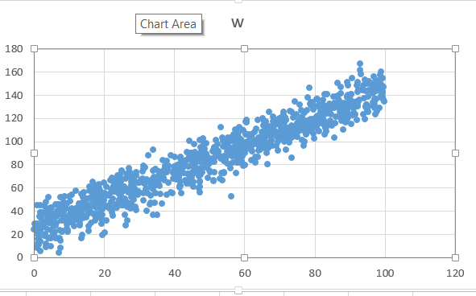

- Have three guesses at the optimum values for m and c and plot them.
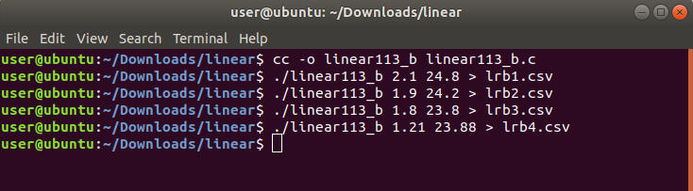

Plotting four values:
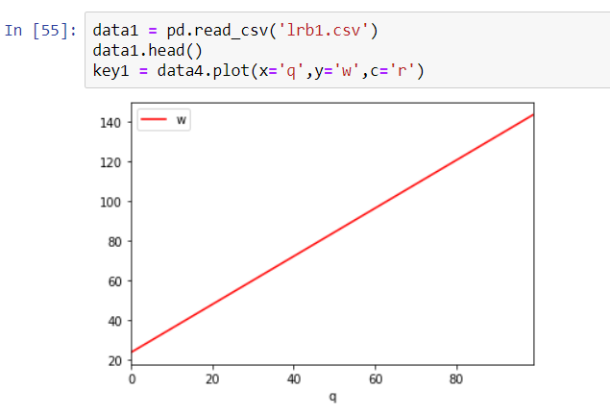
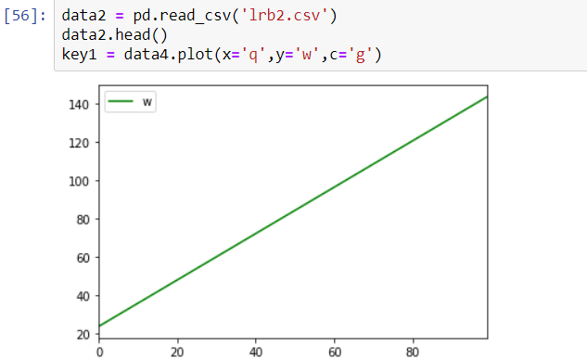
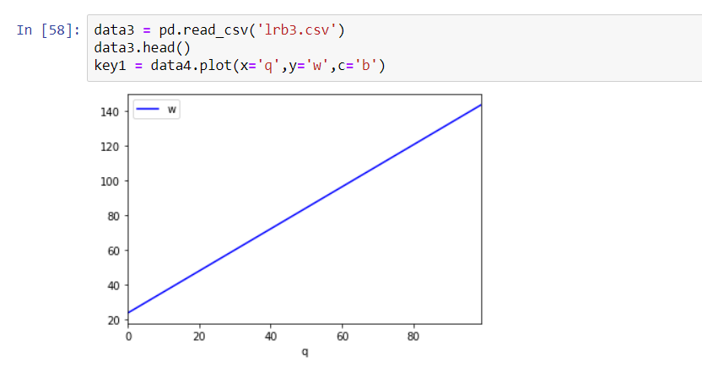

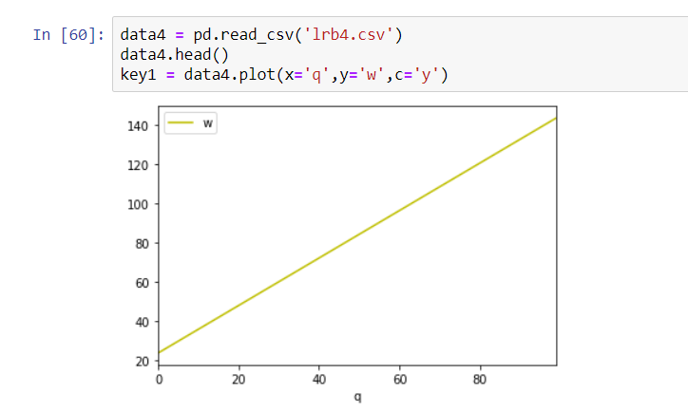

- Run the program to see what solution it finds. Overlay the line that was found by the program on to a dataset scatter plot and comment on the solution.

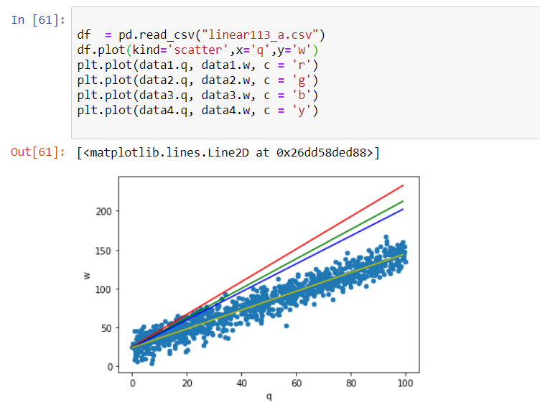
Comment:

- Remove any extraneous printf statements from the program and find its mean running time.

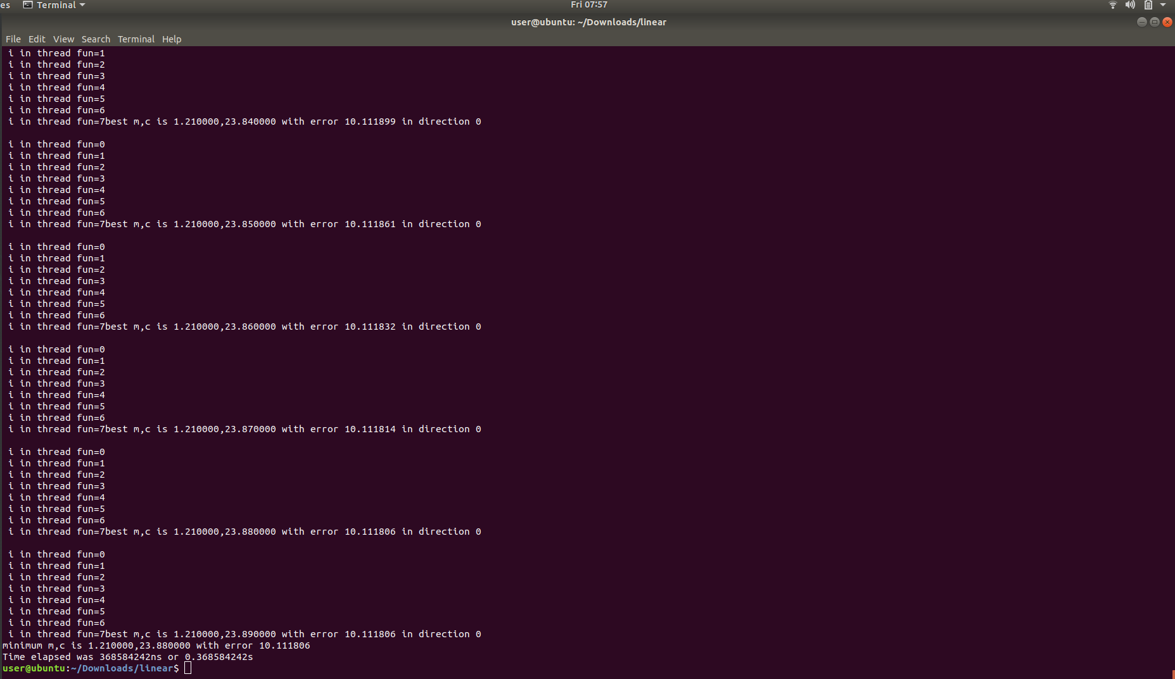
- During each iteration of the program, eight values for m and c are evaluated to measure the resulting error. Create a modified version of the program that performs each of the evaluations on a different thread.

- Calculate the mean running time of the multithread version of the program and use to make comments on the relative performance of the 2 versions.
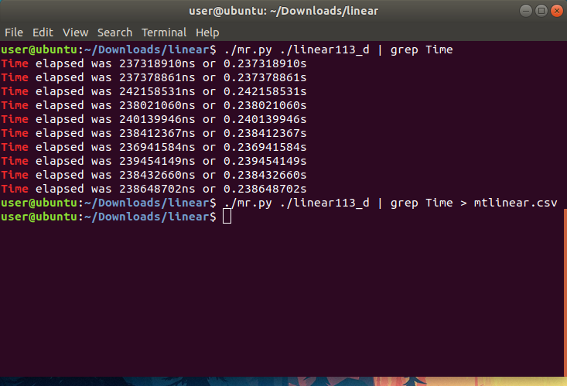
Code of Multithread version:
#include <stdio.h>
#include <math.h>
#include <pthread.h>

double bm = 1.3;
double bc = 10;
double be;
double dm[8];
double dc[8];
double e[8];
double step = 0.01;
double best_error = 999999999;
int best_error_i;
int minimum_found = 0;
double om[] = {0,1,1, 1, 0,-1,-1,-1};
double oc[] = {1,1,0,-1,-1,-1, 0, 1};

typedef struct point_t {
double q;
double w;
} point_t;

int n_data = 1000;
point_t data[];

double residual_error(double q, double w, double m, double c) {
double e = (m * q) + c - w;
return e * e;
}

double rms_error(double m, double c) {
int i;
double mean;
double error_sum = 0;

for(i=0; i<n_data; i++) {
error_sum += residual_error(data[i].q, data[i].w, m, c);
}

mean = error_sum / n_data;

return sqrt(mean);
}

int time_difference(struct timespec *start, struct timespec *finish,
long long int *difference) {
long long int ds = finish->tv_sec - start->tv_sec;
long long int dn = finish->tv_nsec - start->tv_nsec;

if(dn < 0 ) {
ds--;
dn += 1000000000;
}
*difference = ds * 1000000000 + dn;
return !(*difference > 0);
}

void *linear_regression_thread(void *args){

int *a = args;
int i = *a;
printf("\n i in thread fun=%d", i);
dm[i] = bm + (om[i] * step);
dc[i] = bc + (oc[i] * step);

e[i] = rms_error(dm[i], dc[i]);
if(e[i] < best_error) {
best_error = e[i];
best_error_i = i;
pthread_exit(NULL);
}
}

int main() {
struct timespec start, finish;
long long int time_elapsed;
clock_gettime(CLOCK_MONOTONIC, &start);

int i;
pthread_t p_threads[8];

be = rms_error(bm, bc);

while(!minimum_found) {
for(i=0;i<8;i++) {
pthread_create(&p_threads[i], NULL, (void*)linear_regression_thread, &i);
pthread_join(p_threads[i], NULL);
}

printf("best m,c is %lf,%lf with error %lf in direction %d\n",
dm[best_error_i], dc[best_error_i], best_error, best_error_i);

if(best_error < be) {
be = best_error;
bm = dm[best_error_i];
bc = dc[best_error_i];
} else {
minimum_found = 1;
}
}
printf("minimum m,c is %lf,%lf with error %lf\n", bm, bc, be);

clock_gettime(CLOCK_MONOTONIC, &finish);
time_difference(&start, &finish, &time_elapsed);
printf("Time elapsed was %lldns or %0.9lfs\n", time_elapsed, (time_elapsed/1.0e9));

pthread_exit(NULL);
return 0;
}

point_t data[] = {
{79.90,102.68},{77.76,109.55},{65.59,115.28},{82.82,117.35},
{73.39,103.05},{71.84,92.88},{82.91,140.35},{65.88,94.43},
{78.73,111.70},{84.16,132.27},{77.44,117.90},{26.62,58.81},
{49.05,77.92},{64.86,101.36},{24.79,54.12},{64.54,100.68},
{16.88,37.41},{44.27,90.10},{23.05,62.80},{14.81,44.05},
{30.60,67.34},{51.31,94.85},{57.74,81.43},{44.34,70.80},
{43.66,63.79},{53.35,112.16},{ 4.79, 9.74},{42.72,77.99},
{59.99,89.74},{22.98,64.42},{ 7.99,22.19},{ 8.58,48.01},
{89.38,128.43},{90.50,115.22},{19.86,43.86},{12.26,41.42},
{63.97,92.29},{44.21,100.18},{24.52,70.98},{72.87,98.98},
{62.86,107.93},{59.35,93.59},{ 1.77,13.90},{74.78,123.26},
{72.16,110.56},{24.21,54.90},{ 3.57,36.78},{92.57,144.97},
{47.21,60.61},{92.88,161.21},{62.55,100.97},{54.02,100.70},
{16.33,51.79},{17.73,34.24},{41.60,60.47},{92.38,129.99},
{60.12,92.62},{59.09,94.44},{23.36,45.99},{97.42,143.97},
{86.92,135.00},{82.06,125.31},{65.17,119.65},{89.89,138.40},
{55.28,103.51},{ 0.81,44.91},{41.72,61.87},{44.95,69.17},
{59.51,87.37},{50.05,74.77},{43.51,90.83},{95.48,144.13},
{97.19,131.42},{ 4.90,16.45},{36.75,69.19},{27.12,76.99},
{ 4.81,23.53},{82.38,126.49},{ 4.34,32.91},{22.57,56.91},
{17.05,48.27},{17.41,58.73},{18.37,43.79},{18.26,58.11},
{73.26,108.06},{ 8.17,40.94},{73.51,112.13},{42.68,72.57},
{ 0.92,29.01},{77.85,111.53},{31.25,75.88},{24.97,74.89},
{47.60,71.52},{33.28,47.16},{81.31,131.59},{85.43,138.81},
{20.25,53.47},{87.58,117.75},{89.62,130.23},{56.65,82.06},
{20.13,53.60},{84.01,129.12},{70.19,107.15},{13.94,52.01},
{ 2.18,32.65},{15.67,50.73},{20.09,21.49},{91.19,124.47},
{58.38,103.72},{98.08,152.59},{54.60,84.75},{47.19,75.67},
{58.85,98.30},{80.92,115.24},{58.61,111.92},{87.57,121.59},
{63.90,86.69},{47.97,91.85},{49.62,85.89},{37.51,77.45},
{49.23,78.36},{36.87,68.40},{12.80,46.27},{23.75,67.18},
{13.17,29.41},{ 0.86,22.76},{54.28,99.71},{44.77,78.66},
{58.82,93.74},{86.42,129.68},{46.93,82.92},{55.29,98.35},
{89.63,139.09},{58.84,81.77},{57.69,92.35},{32.94,45.88},
{99.40,142.92},{24.77,65.20},{73.30,112.40},{ 8.47,44.98},
{75.17,103.68},{44.53,63.62},{97.36,123.15},{64.29,97.26},
{37.36,78.01},{41.97,82.87},{75.74,111.97},{97.00,144.74},
{14.07,34.13},{26.20,27.30},{54.24,73.19},{60.58,116.48},
{68.68,117.89},{ 2.01,33.68},{27.41,45.97},{99.41,138.95},
{93.94,148.50},{ 6.89,45.60},{48.17,85.03},{ 9.09,34.42},
{65.04,102.82},{45.55,81.01},{89.21,137.63},{99.04,139.64},
{87.48,141.36},{90.76,154.52},{21.92,42.14},{86.15,121.32},
{78.88,108.96},{71.05,125.11},{61.97,98.35},{77.61,106.08},
{54.19,87.07},{72.39,108.38},{ 1.61,35.54},{86.51,130.07},
{56.55,92.94},{66.78,94.45},{41.74,64.96},{13.45,54.41},
{47.60,82.13},{41.34,77.90},{16.21,38.42},{20.07,48.79},
{56.27,100.50},{27.58,41.94},{92.11,148.58},{87.74,122.60},
{18.33,49.19},{46.96,87.21},{20.56,31.85},{59.30,110.48},
{ 0.99, 8.35},{57.78,83.46},{36.52,70.14},{ 3.25,20.24},
{10.31,30.80},{56.05,76.68},{62.26,91.46},{39.08,56.03},
{11.44,34.55},{23.85,62.61},{83.80,128.03},{49.77,80.05},
{93.75,144.13},{ 1.48,16.29},{99.65,147.00},{63.07,100.40},
{51.25,92.74},{94.83,130.87},{89.46,148.62},{ 7.37,23.70},
{ 7.97,23.09},{42.89,80.03},{17.70,43.47},{68.20,109.32},
{19.47,51.95},{29.29,64.47},{79.21,111.63},{41.42,73.90},
{22.13,55.86},{33.86,36.87},{11.48,41.13},{ 8.69,52.26},
{76.12,126.99},{ 9.82,31.71},{11.55,26.85},{65.90,98.14},
{82.91,106.21},{31.10,55.04},{44.88,89.91},{78.13,112.95},
{71.92,112.58},{12.01,42.33},{58.14,87.45},{99.85,134.59},
{53.84,95.85},{ 9.67,32.07},{25.59,61.09},{ 7.13,38.14},
{89.30,139.12},{64.89,99.18},{ 7.65,45.64},{48.52,95.75},
{ 9.37,46.14},{60.58,118.23},{65.06,104.50},{ 3.22,19.33},
{35.54,74.17},{60.35,106.64},{71.19,122.79},{61.96,92.84},
{81.24,118.97},{ 9.22,42.33},{21.89,66.69},{73.78,113.06},
{45.98,79.38},{69.11,108.12},{84.75,123.00},{77.99,138.17},
{29.25,40.48},{59.80,99.18},{43.12,66.18},{78.44,146.38},
{23.09,64.80},{73.45,113.59},{ 2.17,27.33},{23.96,45.40},
{39.98,78.55},{22.35,68.78},{75.08,116.04},{81.82,123.13},
{92.52,134.38},{27.67,68.37},{79.02,117.78},{20.64,61.16},
{22.17,38.47},{34.26,63.39},{76.49,101.49},{44.96,72.96},
{ 5.34,18.79},{85.39,131.64},{40.03,74.87},{90.71,133.04},
{79.62,131.19},{13.73,19.42},{13.69,43.31},{93.78,123.36},
{71.33,106.95},{13.67,47.22},{33.23,63.54},{30.52,65.69},
{32.05,59.57},{ 1.11,12.65},{89.21,125.48},{27.67,65.31},
{15.50,37.72},{71.34,99.74},{ 9.68,31.18},{31.27,49.32},
{80.43,117.44},{92.87,166.82},{68.43,113.19},{97.11,136.49},
{47.58,77.21},{18.94,37.41},{50.68,84.05},{19.74,45.95},
{ 7.65,14.32},{54.69,84.33},{18.97,57.10},{71.62,120.29},
{60.18,95.13},{18.04,52.45},{51.67,90.35},{10.66,34.40},
{96.57,130.81},{18.98,41.00},{94.84,132.01},{97.34,151.92},
{49.18,77.65},{36.06,68.86},{77.03,124.89},{69.48,103.30},
{92.28,142.75},{11.14,36.42},{23.78,70.67},{61.56,104.01},
{18.59,55.37},{50.93,85.42},{54.07,72.63},{13.56,16.59},
{75.61,118.15},{29.99,64.71},{13.24,38.87},{99.64,135.59},
{68.16,117.25},{92.24,151.11},{64.01,103.55},{ 3.41, 8.74},
{44.29,87.41},{91.50,123.46},{ 4.27,39.84},{89.37,151.24},
{80.37,113.21},{30.97,67.71},{38.00,76.21},{73.37,85.70},
{ 6.29,45.76},{41.55,75.07},{19.39,36.33},{ 1.22,21.94},
{ 6.45,16.63},{85.00,113.93},{74.23,108.92},{78.44,118.45},
{25.67,47.33},{53.41,73.01},{ 2.59,26.88},{69.54,99.49},
{70.41,106.23},{66.30,96.53},{ 2.37,38.86},{87.28,125.15},
{82.39,135.72},{63.02,81.43},{ 0.01,24.29},{29.05,73.73},
{18.18,56.44},{51.69,91.81},{65.44,105.29},{61.28,105.41},
{27.98,61.70},{18.83,42.26},{62.06,95.75},{16.20,29.84},
{56.12,89.22},{24.07,55.35},{60.41,117.28},{96.99,134.49},
{47.20,100.81},{12.15,32.54},{ 5.88,27.48},{ 1.91, 5.54},
{72.20,106.06},{45.23,82.58},{18.49,46.03},{67.55,111.49},
{ 2.94,44.19},{90.54,140.45},{45.34,64.87},{75.65,110.87},
{42.46,77.35},{10.28,48.16},{33.96,59.06},{83.93,125.99},
{84.63,114.05},{17.99,33.60},{71.36,116.19},{20.86,43.28},
{57.39,98.78},{37.82,82.86},{31.57,77.70},{ 5.42,27.81},
{23.07,42.68},{58.40,81.45},{67.23,104.47},{79.71,119.42},
{ 3.50,47.91},{84.47,123.91},{70.69,103.13},{65.15,95.10},
{77.95,109.85},{ 4.26,35.46},{25.54,44.77},{78.47,109.50},
{ 3.88,35.22},{63.87,118.33},{53.15,85.02},{89.58,120.68},
{95.09,151.76},{47.05,69.60},{12.65,43.14},{40.94,79.82},
{37.09,66.64},{70.12,107.78},{96.28,149.34},{69.98,116.02},
{80.46,112.65},{55.08,81.27},{28.81,58.25},{95.27,129.45},
{78.18,109.61},{35.56,63.23},{61.80,96.00},{26.32,71.76},
{57.06,105.17},{68.61,108.56},{41.76,84.86},{45.67,77.38},
{18.08,62.41},{ 3.97,24.13},{32.13,40.14},{21.14,53.98},
{23.24,56.53},{54.77,94.83},{47.71,91.16},{55.41,88.20},
{91.39,134.04},{13.68,37.00},{69.60,91.90},{56.36,88.47},
{ 3.05,31.12},{95.09,126.80},{12.21,40.92},{47.35,64.77},
{96.65,133.52},{65.93,109.36},{ 7.19,40.64},{28.59,59.71},
{ 2.91,18.47},{39.76,67.70},{79.67,127.83},{77.86,112.61},
{83.27,108.63},{26.76,56.29},{ 5.24,32.30},{33.76,61.06},
{48.07,85.35},{83.48,124.03},{10.76,53.71},{11.67,38.05},
{35.06,36.33},{10.85,41.98},{63.39,110.88},{65.43,113.58},
{88.23,131.37},{48.12,102.72},{86.44,150.17},{ 1.03,10.31},
{23.83,46.58},{56.38,94.45},{25.07,45.14},{46.11,76.92},
{19.53,19.19},{48.75,87.33},{14.84,34.58},{ 0.55,27.38},
{37.82,54.22},{99.07,148.20},{94.40,119.48},{49.09,80.06},
{82.33,120.78},{57.70,72.77},{18.51,59.77},{40.84,69.86},
{ 1.94,38.97},{66.42,90.30},{21.43,53.49},{13.73,43.46},
{25.51,47.24},{12.90,36.65},{16.74,64.86},{53.64,66.45},
{98.74,157.15},{83.19,111.72},{25.16,56.99},{63.04,86.92},
{22.51,50.18},{33.87,74.90},{55.03,91.65},{45.97,72.94},
{36.69,83.72},{47.53,88.14},{52.79,88.31},{49.18,81.30},
{34.66,75.99},{94.46,143.80},{60.06,79.32},{18.79,51.09},
{49.11,98.35},{20.13,52.26},{73.85,120.45},{ 0.12,28.76},
{98.91,137.99},{70.88,121.87},{61.44,106.18},{85.52,103.13},
{63.33,97.79},{56.56,87.01},{ 7.34,16.82},{65.80,109.63},
{ 3.42,30.43},{51.24,65.55},{38.91,87.94},{87.44,146.69},
{67.04,113.11},{69.98,114.23},{ 8.55,42.17},{71.73,118.35},
{32.41,55.69},{75.44,108.94},{98.65,150.17},{13.18,27.60},
{54.24,82.99},{ 4.05,16.50},{97.17,128.99},{62.25,106.12},
{13.72,40.09},{10.38,33.18},{97.85,144.76},{19.52,41.56},
{21.56,42.37},{92.00,134.12},{ 1.08,19.12},{73.04,102.48},
{51.42,73.69},{ 7.09, 3.85},{95.85,143.68},{89.04,123.52},
{34.48,67.27},{77.11,108.57},{55.47,80.37},{10.41,33.94},
{71.85,104.22},{57.47,94.50},{59.04,89.25},{29.06,70.84},
{98.43,129.05},{38.27,78.99},{37.50,73.67},{ 1.71,27.63},
{22.67,57.90},{44.29,84.96},{60.23,90.39},{26.65,32.04},
{42.01,74.26},{58.48,90.52},{51.93,91.11},{80.88,116.81},
{33.40,64.65},{47.94,73.39},{56.45,102.05},{28.47,49.51},
{73.06,125.91},{67.63,105.48},{34.76,64.29},{23.53,43.08},
{52.15,87.25},{31.52,64.00},{96.82,132.15},{70.50,111.37},
{28.19,54.53},{74.43,111.61},{69.95,119.72},{30.96,74.04},
{96.73,141.14},{40.79,73.73},{37.91,73.58},{44.08,78.10},
{67.75,101.18},{79.55,118.51},{71.41,110.73},{76.81,96.06},
{79.95,112.41},{48.23,81.65},{45.82,90.45},{12.58,40.22},
{22.13,47.78},{61.48,96.92},{ 9.69,22.35},{13.89,52.29},
{94.97,126.80},{74.87,110.07},{85.62,128.73},{45.05,72.85},
{24.30,49.87},{17.42,31.66},{45.71,87.02},{91.62,131.80},
{89.60,128.80},{48.07,86.91},{45.39,60.61},{39.73,74.05},
{73.80,104.54},{27.72,51.94},{70.83,106.13},{93.09,158.08},
{49.94,85.04},{45.26,78.62},{66.92,108.34},{35.56,69.52},
{94.51,129.25},{94.71,131.39},{29.80,56.47},{36.80,74.08},
{48.42,98.18},{ 3.59,41.93},{60.71,99.79},{18.18,49.29},
{59.57,95.33},{83.75,128.40},{56.16,93.52},{75.74,131.81},
{ 7.82,41.58},{95.48,151.94},{89.92,122.52},{99.46,154.82},
{27.76,62.35},{ 1.76,23.67},{64.68,104.03},{66.21,104.69},
{24.17,45.82},{26.02,36.83},{17.09,56.58},{99.30,142.01},
{96.18,143.94},{68.03,96.51},{32.55,87.67},{27.90,69.92},
{26.67,46.75},{59.33,83.36},{ 6.54,40.05},{ 4.40,30.04},
{95.27,138.85},{11.97,57.72},{29.07,54.35},{18.66,52.10},
{14.90,50.22},{86.96,131.11},{57.03,89.69},{ 7.51, 8.17},
{27.75,46.46},{71.63,111.80},{33.77,59.71},{ 9.30,28.48},
{68.98,118.34},{28.31,58.70},{82.09,132.57},{16.84,53.11},
{85.58,131.05},{22.16,41.32},{44.42,71.69},{ 5.04,36.28},
{ 3.07,26.54},{88.24,110.17},{17.34,61.47},{88.35,133.35},
{83.51,140.65},{51.13,66.38},{92.83,136.16},{78.89,119.31},
{15.53,38.27},{51.48,82.57},{50.33,81.92},{84.56,117.61},
{10.60,37.17},{ 5.09,35.42},{50.99,83.66},{27.48,46.35},
{58.36,95.56},{80.50,120.98},{98.95,143.36},{82.44,114.75},
{52.03,93.00},{47.11,88.68},{41.80,81.32},{21.99,59.18},
{61.94,83.49},{81.77,125.27},{45.87,74.98},{10.71,37.49},
{39.69,72.74},{81.24,129.61},{68.24,121.53},{69.33,104.32},
{26.08,67.82},{52.44,97.72},{52.94,67.97},{31.91,58.91},
{15.18,42.19},{97.55,149.23},{70.24,118.24},{ 7.65,39.91},
{12.59,32.96},{35.32,69.95},{14.37,47.17},{58.91,101.71},
{41.36,69.83},{44.69,67.78},{90.39,141.01},{24.38,70.10},
{12.07,33.81},{70.09,115.05},{65.47,118.61},{57.97,108.72},
{35.50,66.73},{48.74,93.37},{81.23,109.05},{35.89,61.33},
{ 4.85,43.22},{92.12,118.49},{73.10,103.28},{13.54,39.39},
{14.24,55.73},{92.33,130.82},{65.04,107.97},{69.41,116.16},
{89.22,119.44},{15.65,26.70},{19.86,64.28},{68.39,115.53},
{24.81,68.16},{84.72,130.36},{73.56,125.16},{85.26,129.05},
{72.38,103.12},{82.41,126.89},{47.39,66.00},{20.88,44.34},
{77.91,127.00},{95.29,125.20},{32.20,65.03},{43.51,63.98},
{44.26,85.34},{49.33,87.08},{41.57,79.58},{81.95,128.48},
{53.82,103.47},{10.20,52.73},{11.01,34.13},{49.07,89.21},
{95.11,149.64},{77.03,99.62},{49.88,80.32},{43.46,84.02},
{85.89,115.52},{ 5.88,22.14},{69.13,96.13},{80.71,122.24},
{43.59,84.14},{ 1.48,27.62},{94.04,137.29},{40.56,67.51},
{26.62,43.52},{67.74,100.69},{25.39,60.79},{ 6.09,27.67},
{24.83,51.43},{33.38,53.44},{10.69,35.13},{75.91,117.39},
{28.11,59.32},{66.53,109.71},{10.13,36.77},{ 6.37,35.20},
{40.14,86.83},{89.53,140.14},{28.09,52.80},{ 1.16,16.05},
{22.48,35.99},{56.34,94.18},{57.46,110.00},{34.17,69.52},
{91.05,128.47},{61.62,93.65},{15.90,45.22},{34.02,93.05},
{41.44,61.77},{45.63,97.43},{67.90,112.22},{35.22,63.07},
{75.93,116.84},{36.48,46.53},{71.89,118.75},{76.61,113.47},
{60.02,93.52},{46.42,85.15},{86.99,121.08},{33.73,67.46},
{72.18,105.95},{79.36,133.73},{43.89,72.20},{47.01,59.64},
{64.42,93.03},{19.18,29.25},{11.82,37.32},{ 3.85,32.04},
{56.94,105.96},{ 6.42,29.65},{80.87,136.64},{96.96,156.04},
{34.45,46.95},{35.93,54.63},{ 9.69,23.24},{ 5.24,32.82},
{70.06,114.22},{27.81,46.06},{13.71,44.87},{88.87,131.99},
{34.70,55.52},{ 5.04,42.79},{66.46,96.93},{46.14,84.13},
{49.63,68.51},{27.23,69.76},{58.58,91.20},{ 9.39,24.66},
{ 4.17,51.69},{26.52,47.23},{97.89,126.25},{86.62,139.05},
{74.59,105.74},{37.50,78.76},{79.68,106.57},{18.50,63.19},
{51.94,101.10},{22.80,61.88},{65.72,94.91},{25.70,60.76},
{ 7.73,31.53},{ 5.57,20.71},{82.60,130.78},{90.85,122.42},
{83.72,125.75},{94.42,153.42},{ 1.28,10.95},{41.72,86.49},
{52.55,91.78},{ 5.62,20.58},{76.34,121.09},{66.07,116.86},
{79.67,114.51},{71.69,106.33},{42.07,55.12},{56.39,103.78},
{85.73,133.22},{10.85,30.35},{15.21,50.53},{92.16,131.66},
{27.27,73.43},{59.65,109.68},{15.14,41.31},{41.32,68.31},
{69.12,116.98},{60.47,105.83},{18.33,51.57},{13.52,46.55},
{ 8.10,36.65},{50.76,82.11},{47.22,55.85},{ 8.25,31.71},
{78.63,132.22},{64.95,103.16},{21.63,45.15},{45.55,87.93},
{89.75,133.17},{35.57,67.92},{97.58,136.22},{65.84,100.78},
{15.86,57.21},{77.96,112.20},{18.14,56.11},{ 1.56,22.06},
{68.79,116.16},{67.13,125.74},{99.12,143.58},{ 8.50,32.79},
{57.76,86.15},{86.68,136.19},{87.64,126.61},{83.69,113.47},
{77.24,112.34},{74.46,104.82},{17.39,57.76},{80.59,111.30},
{81.33,121.99},{30.93,66.93},{88.89,128.51},{84.14,128.61},
{74.22,106.71},{17.48,52.82},{47.41,95.12},{64.28,95.16},
{47.56,89.35},{65.66,102.54},{58.38,107.34},{64.08,102.07},
{73.71,105.10},{74.39,134.41},{98.12,147.84},{28.06,62.71},
{50.90,91.66},{98.96,160.26},{90.33,135.36},{58.46,89.04},
{78.98,133.43},{17.59,37.71},{45.61,76.55},{ 2.33,25.67},
{36.44,71.34},{19.08,53.87},{17.45,43.43},{19.20,33.23},
{ 1.78,44.95},{36.86,74.93},{69.28,105.93},{56.51,91.82},
{14.68,44.82},{15.93,42.16},{50.19,73.65},{99.06,143.58},
{86.73,133.87},{63.45,85.73},{80.58,136.78},{28.36,66.89},
{88.33,131.15},{ 7.99,39.17},{56.34,52.79},{10.90,30.00},
{29.52,54.17},{78.41,116.72},{23.19,58.48},{15.68,22.87},
{ 3.54,11.53},{ 7.66,51.64},{82.30,127.49},{13.63,43.91},
{25.90,50.49},{88.89,116.67},{ 6.14,16.22},{31.12,79.05},
{78.99,130.96},{56.92,95.13},{17.62,47.66},{38.35,64.44},
{ 5.18,38.05},{33.94,67.21},{20.11,55.17},{57.53,101.99},
{28.94,43.51},{97.50,143.58},{66.05,94.54},{24.41,58.39},
{34.85,62.45},{69.21,104.18},{10.45,39.35},{ 2.75,38.16},
{32.16,67.34},{80.87,118.93},{ 8.50,39.76},{39.56,55.55},
{62.56,99.80},{ 4.73,32.53},{59.74,79.12},{ 8.38,41.05},
{94.59,130.11},{66.55,80.04},{ 8.71,42.41},{15.83,60.68}
};

